 |  | INTERNATIONAL TELECOMMUNICATION UNION  TELECOMMUNICATION  STANDARDIZATION SECTOR  STUDY PERIOD 2025-2028 |  |  |  | SG12–Cxx
 |  |  |  |  |  | STUDY GROUP 12
 |  |  |  |  |  | Original: English
 | Question(s): |  |  | 19/12 |  | Online, 17 December 2025​​
 | CONTRIBUTION
 | Source: |  |  | NTT
 | Title: |  |  | Training experiment results of AV1 encoded video for the coding extension of P.1199.
Contact: |  |  | Masanori Koike  Japan  NTT |  | Tel: +81-422-59-4453  E-mail: masanori.koike@ntt.com
Contact: |  |  | Kazuhisa Yamagishi  Japan  NTT |  | Tel: +81-422-59-4397  E-mail: kazuhisa.yamagishi@ntt.com
Contact: |  |  | Yoichi Matsuo  Japan  NTT |  | Tel: +81-422-59-4519  E-mail: yoichi.matsuo@ntt.com
Contact: |  |  | Kimiko Kawashima  Japan  NTT |  | Tel: +81-422-59-7839  E-mail: kimiko.kawashima@ntt.com

Abstract: | Recommendation P.1199, Parametric object-recognition-ratio-estimation model for remote monitoring of surveillance video delivered from autonomous vehicle, was published in the SG12 meeting in November 2025. This recommendation supports the use of H.265-encoded video. To additionally support for AV1 on the P.1199 model, a training experiment for AV1 videos was conducted, and the results are presented in this contribution.

- Introduction
Recommendation P.1199 is a parametric object-recognition-ratio-estimation model in surveillance video of autonomous driving, which supports H.265/HEVC encoded videos. Since the object-recognition ratio, which is the output of P.1199, is affected by the codec of the surveillance video, the coefficients of the model must be optimized in accordance with the codec when the surveillance video codec is changed. To additionally support for AV1 on the P.1199 model, the model extension procedure [1], Terms of Reference (ToR) [2], and Test Plan [3] were proposed in the SG12 meeting in September 2025. The agreed on model extension procedure is to conduct training and validation experiments, after which P.1199 will be revised. The training and validation procedure, and the ToR and Test Plan are the same as those in the current P.1199, except for the encoding method. This contribution presents the results of the training experiment and the model’s performance.

- Subjective Experiment
  - Source Reference Circuits (SRC)
To obtain the result of the object-recognition ratio for training data, subjective experiments were conducted in accordance with the ToR [2] and Test Plan [3]. Ninety daytime source videos, called source reference circuits (SRCs), were obtained by a surveillance camera on the front of a car in this experiment. First, eight anchor SRCs were prepared to compare participant tendencies between training and validation tests and to obtain the subjective object-recognition ratio. Second, 10 dummy SRCs were prepared to prevent participants from anticipating the appearance of the child who appeared in the SRCs. That is, these dummy SRCs do not contain any child or other objects (e.g., traffic cones). Third, 72 SRCs in which a child appeared were prepared for obtaining the subjective object-recognition ratio. To examine the effect of velocity on object recognition, 72 SRCs are allocated to one of four velocity conditions (10, 20, 30, and 40 km/h), as shown in Table 1.
Each SRC lasted 25 to 35 seconds and a child (i.e., 120 cm) appeared suddenly from behind a building between 20 and 30 seconds into the SRCs. Because the stopping distance increases as velocity increases, the distance between the vehicle and the child varies with its velocity: 36.8 m at 40 km/h, 25.9 m at 30 km/h, 16.1 m at 20 km/h, and 7.5 m at 10 km/h. The resolution of the source video was 1920 x 1080/59.94 fps (Chroma sampling: 4:2:0). Examples of thumbnails are shown in Figure 1. The SRCs have no audio.

Table 1: The number of SRCs by velocity
 | Velocity (km/h)
 | 10 | 20 | 30 | 40
The number of SRCs | 16 videos | 16 videos | 20 videos | 20 videos

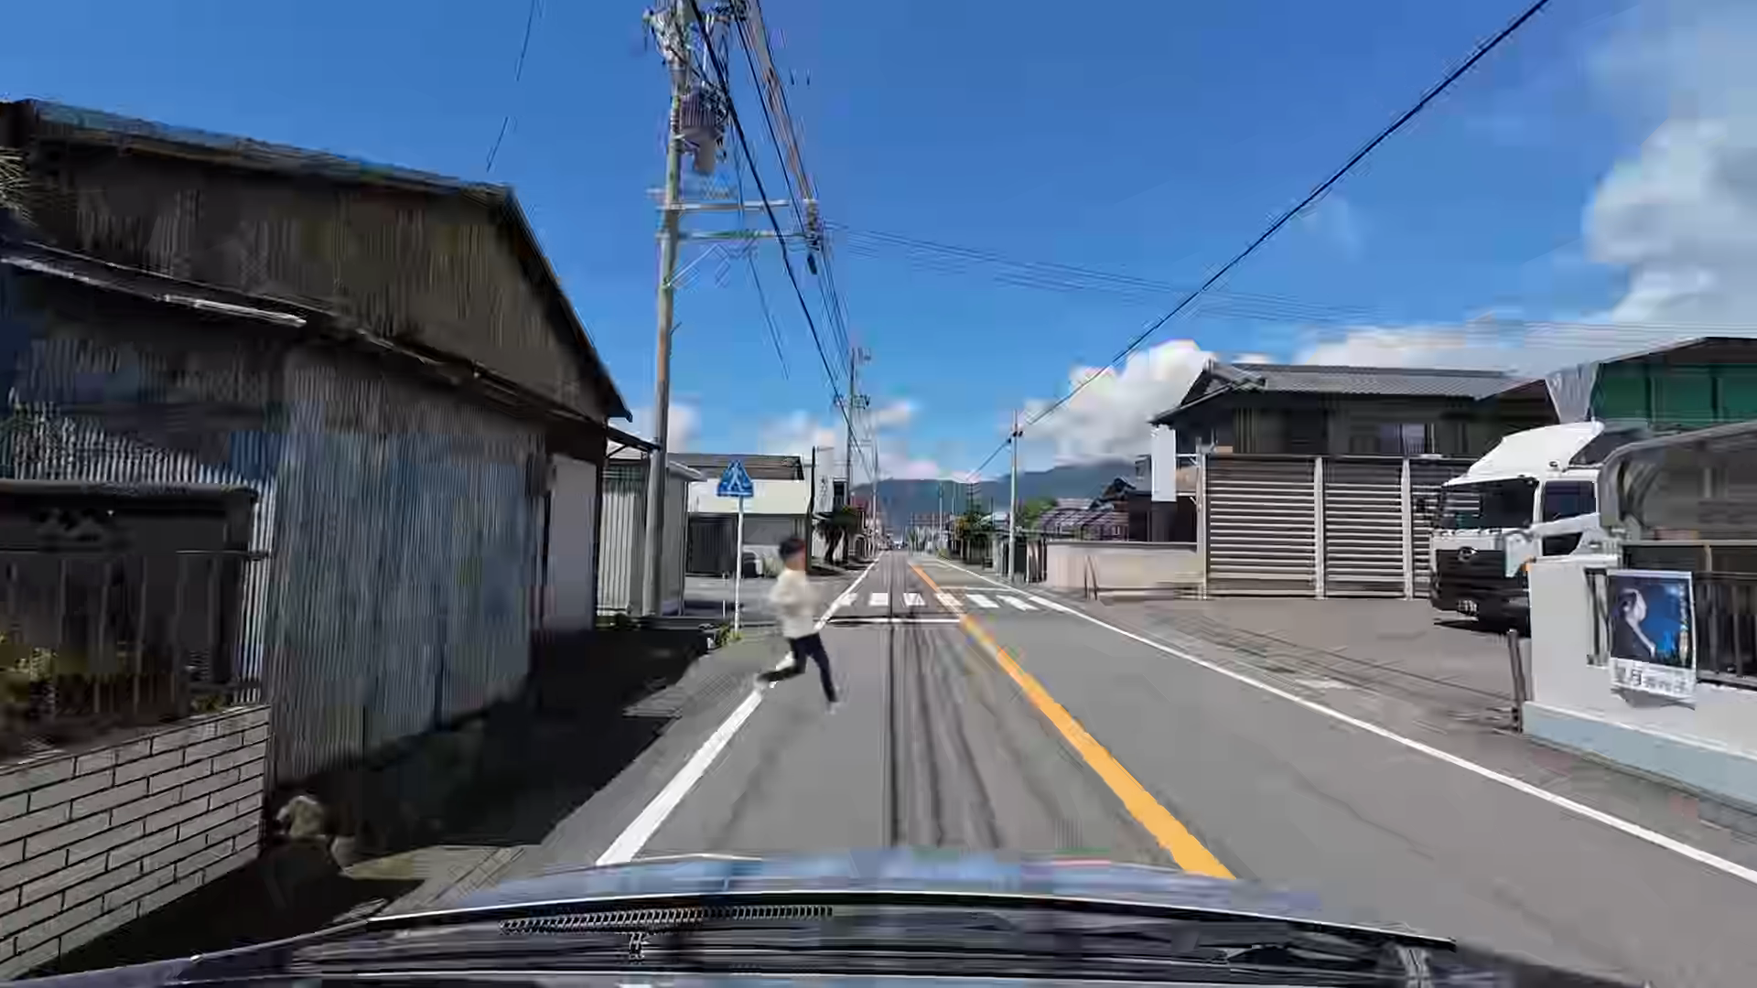  1000 kbps, 30fps, 10km/h | 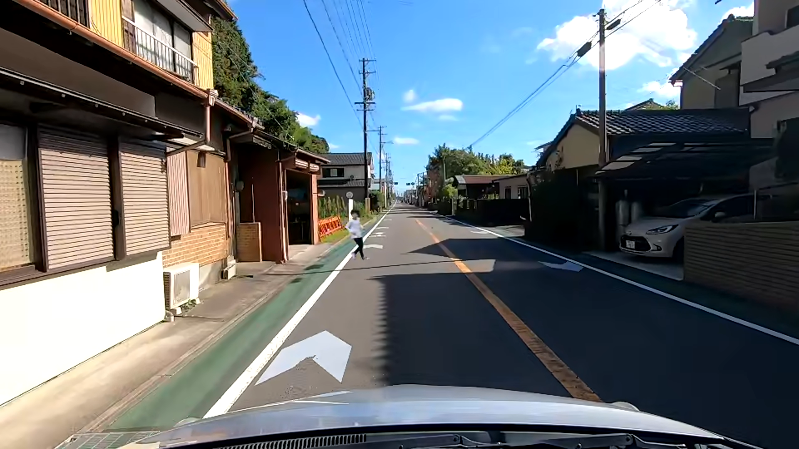  2000kbps, 15fps, 20km/h
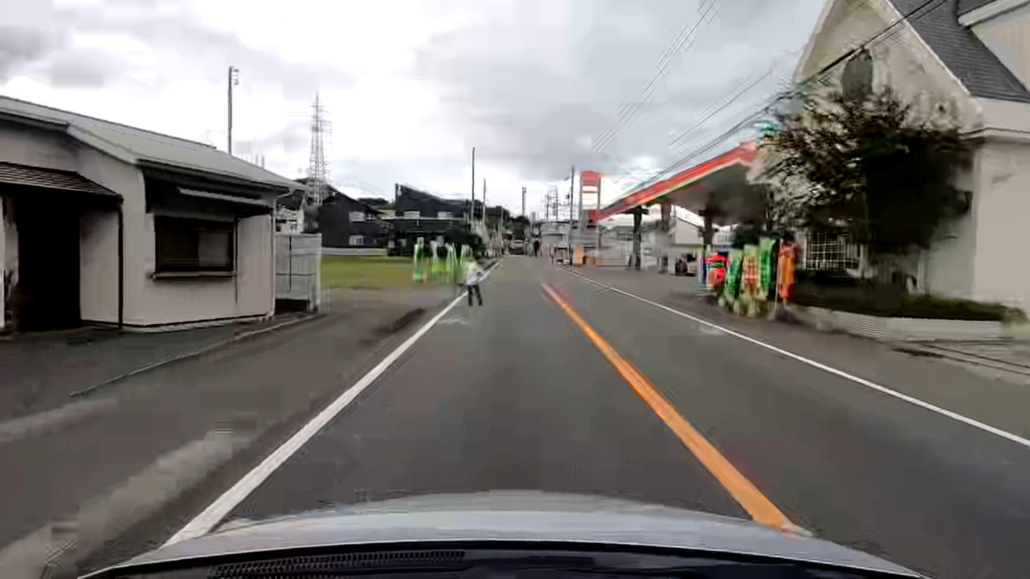  500kbps, 30fps, 30km/h | 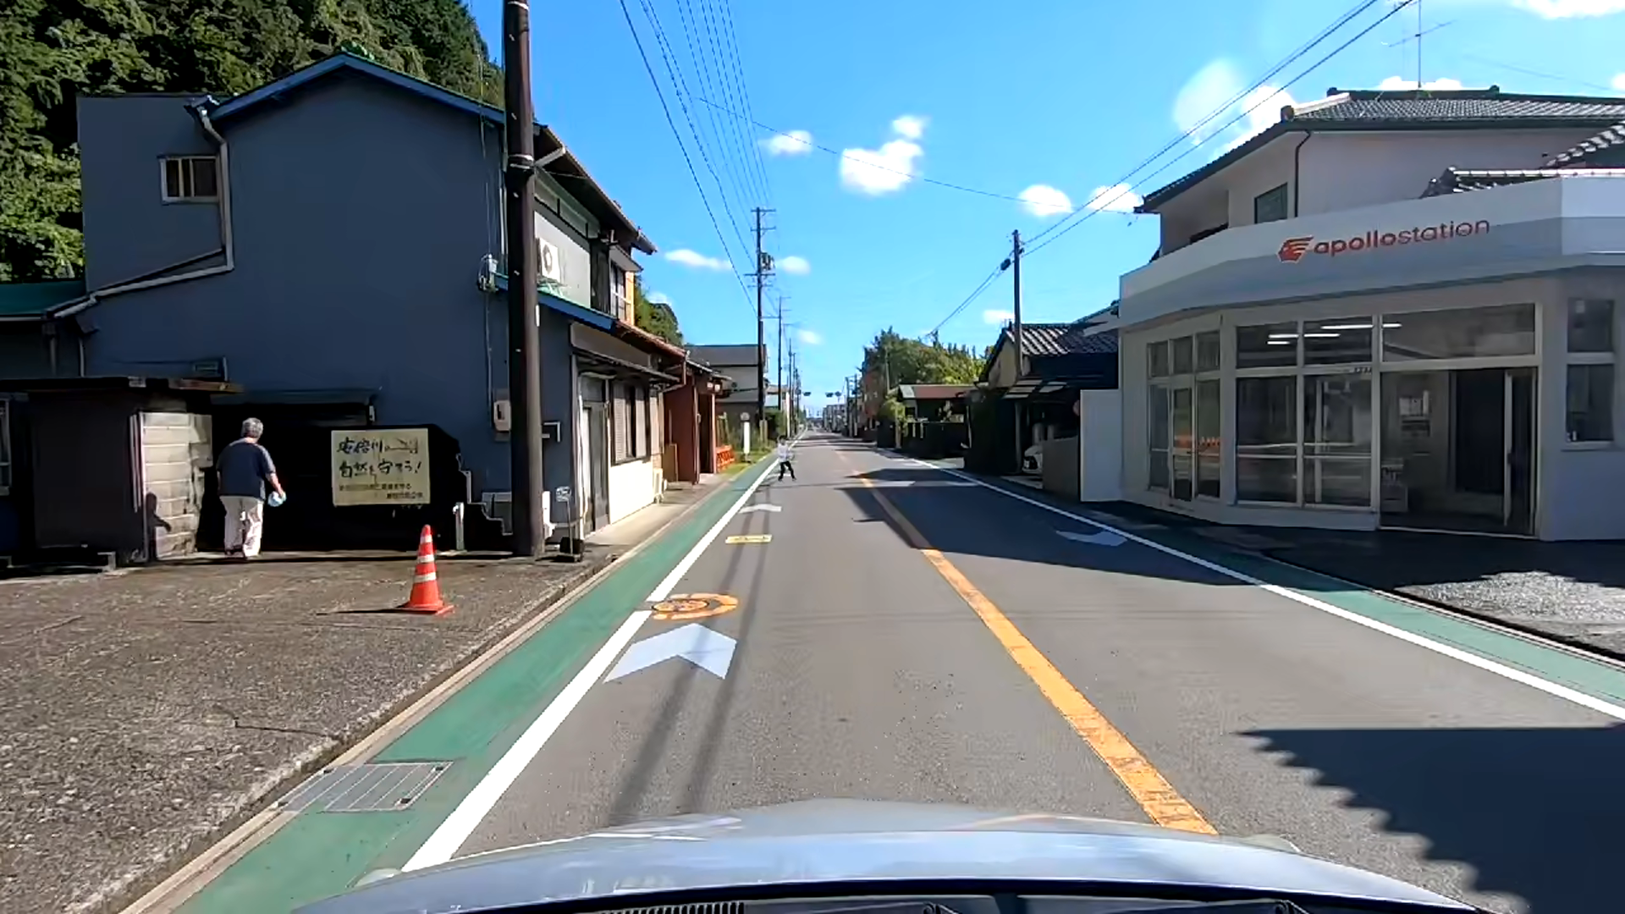  5000kbps, 15fps, 40km/h
Figure 1: Examples of thumbnails

  - Hypothetical Reference Circuits (HRC)
Experimental conditions, called hypothetical reference circuits (HRCs), are described in this subsection. SRCs were encoded with AV1 video coding (GOP: 1 second, IPP). There were several bitrate, resolution, framerate, velocity, and packet-loss patterns, as detailed in Table 2. The maximum bitrate condition of 40 Mbps was prepared for the same quality as a reference SRC. This HRC is used for obtaining the saturated object-recognition ratio to train the proposed model. For packet-loss concealment, a frozen video frame is used, i.e., when packet loss occurs, the video frames are frozen (i.e., no block distortion due to packet loss is shown). Note that the measured values of video bitrate and packet loss were different from the set values. Therefore, the measured bitrate and packet loss are used to estimate the object-recognition ratio.

Table 2: Setting values
Quality factors | Parameter setting
Bitrate (kbps),  Resolution | 360p: 60-1000kbps  540p: 80-2000kbps  720p: 200-5000kbps  1080p: 1000-5000kbps, 40000kbps (for reference)
Framerate (fps) | 10, 15, 30, 60
Velocity (km/h) | 10, 20, 30, 40
Packet loss rate | 0,3,5,7,10%

  - Processed Video Sequences (PVSs)
The processed video sequences (PVSs) were generated as follows. First, each SRC was encoded at a specific setting on the basis of HRC with AV1. Next, an encoded video was packetized and delivered. Then, Wireshark captured the delivered packets. After the delivered packets were captured, lost packets were determined in accordance with a set packet-loss rate, and packets determined to be lost were removed. The video frames containing the lost packets or P-frames with lost referenced frames were frozen.
In the training experiment, 72 SRCs were encoded in 4 patterns (288 PVSs). Besides these PVSs, eight anchor PVSs and 10 dummy PVSs are encoded by assigning 1 HRC per SRC.
  - Subjective Experiment Procedures
Before the subjective experiment, participants read the instructions to understand the procedure and the object of the experiment. They also took visual acuity and color vision tests. Then, participants moved on to the training test. In the training test, participants watched 10 PVSs in 1 session that lasted about 5 minutes. After the training session, participants moved on to the main test. During the main test, participants watched 10 PVSs in 1 session the same as in the training test, and they did 9 sessions (i.e., participants watched 90 PVSs). There were 2-minute breaks between sessions and 10-minute breaks every 2 sessions. The whole experiment lasted about 150 minutes, including visual acuity and color vision tests, instruction, tests, and breaks.
The participants monitored the PVSs using special software for object recognition. When the participants saw that a person had stepped onto the sidewalk or objects were placed on the road, they clicked the mouse and the video stopped. Their reaction time were measured, and were used to calculate the object-recognition ratio. After clicking the mouse, the next video was displayed on the screen. The details of the test procedure are given in the Test Plan [3].

  - Subjective Experiment Participants
The experiments were conducted by 128 participants (training: 64 males and 64 females ranging from 18 to 51 years old, the average age is 22) who had passed the visual acuity and color vision tests. In this experiment, participants were divided into four groups, and participants in each group were assigned to watch a different PVS so that each PVS was watched by 32 participants.

  - Derivation of Object-Recognition Ratio
The object-recognition ratio is the percentage of participants who can recognize objects in the surveillance video and click the mouse within the time it is possible to avoid a collision after the objects appear at the target distance from the autonomous car. The calculation of the object-recognition ratio is described in detail in Section 3.5 of the Test Plan [3]. In this experiment, the required reaction time was set to one second. Therefore, if the participants could recognize and click the mouse within one second, it was judged that the object could be recognized. The reaction time is explained in detail in Appendix II. Note that the I frame randomly appears within the one second where the object appears.
- Experimental Results
  - Screening of Participants
Before analyzing the object-recognition ratio data, in this experiment, participants were screened in the same way as in the previous training experiment [4]. Since the participants with low correlation coefficients had low object-recognition ratios for overall object recognition, they were considered inappropriate for inclusion in the training dataset. Thus, the 4 participants with a correlation coefficient of 0.5 or lower were screened out, leaving 124 participants.
  - Coefficients Optimization of the Proposed Model
In Recommendation P.1199, the model formula and coefficients for H.265/HEVC are shown. To extend the P.1199 model to AV1 codec, the coefficients will be optimized without changing the model formula. In this contribution, the model extended from P.1199 model to AV1 is defined as the proposed model. By using the subjective object-recognition ratio of 288 PVSs obtained in this training experiment, the coefficients of the proposed model are trained. The object-recognition ratio is estimated by using the trained coefficients, and the estimation accuracy was verified.

  - Performance of the Proposed Model to AV1 Codec
Scatter plots of the results are shown in Figure 2. In these figures, the horizontal and vertical axes show the estimated and subjective object-recognition ratios, respectively. These figures show that although the estimation accuracy varied from mode to mode, except for some PVSs, the plots were distributed along a 45-degree line. The Root Mean Square Error (RMSE) and Pearson Correlation Coefficient (PCC) rounded off to three decimal places are shown in Table 3.
To compare the results of the AV1 codec with the previous results encoded using the H.265 codec, the H.265 experimental results [6] are presented in Table 4. Since the estimation accuracy of AV1 has reached a level equivalent to H.265, it has been sufficiently trained and can be moved to the verification phase.

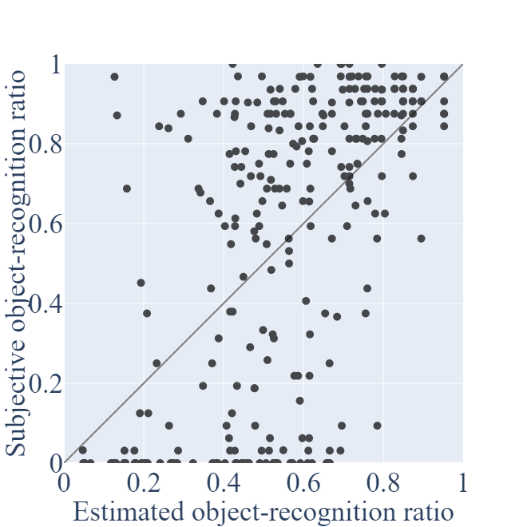  a) Mode 0 | 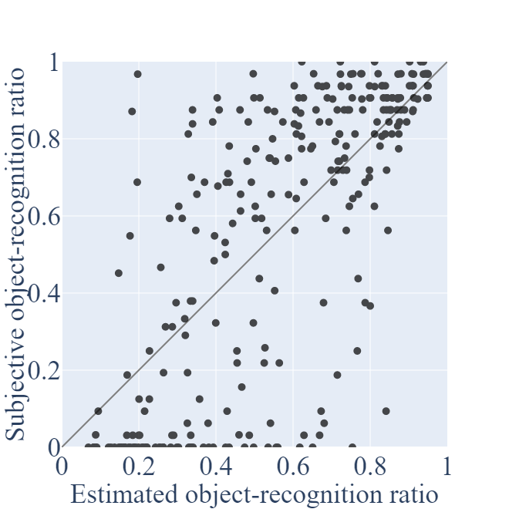  b) Mode 1
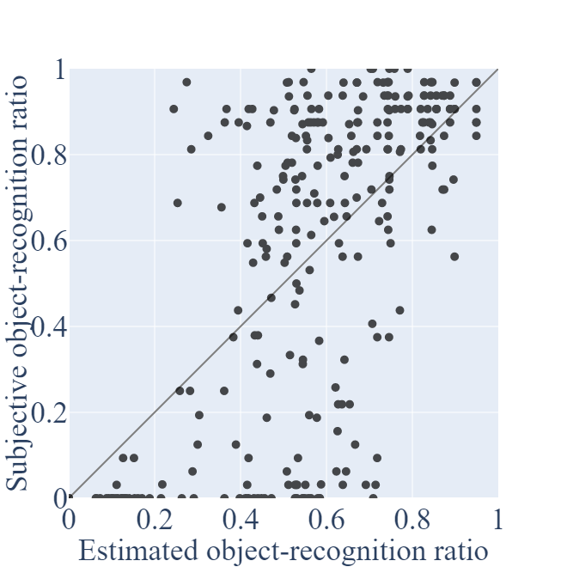  c) Mode 2 | 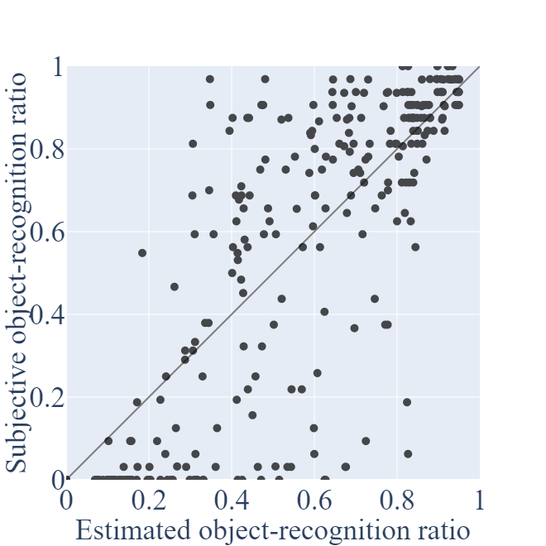  d) Mode 3
Figure 2: Performance of the Model

Table 3: RMSE and PCC of the proposed model
 | Mode 0 | Mode 1 | Mode 2 | Mode 3
RMSE | 0.303 | 0.284 | 0.254 | 0.226
PCC | 0.583 | 0.649 | 0.733 | 0.797

Table 4: RMSE and PCC of H.265 encoded video
 | Mode 0 | Mode 1 | Mode 2 | Mode 3
RMSE | 0.341 | 0.292 | 0.295 | 0.231
PCC | 0.434 | 0.636 | 0.633 | 0.795

  - Performance of Baseline Model
The performance of the baseline model is described in this subsection. The baseline model was the minimum requirement for the overall model performance, and was agreed on in the previous meeting. The model is computed by using a simple mapping of the second-order bitrate to the subjective object-recognition ratio. Specifically, the object-recognition ratio $R_{baseline}$ predicted by the baseline model is
$R_{baseline}=c_{1}*b^{2}+c_{2}*b+c_{3}$,
where $b$ is the bitrate of PVS and the parameters $c_{1}-c_{3}$ are coefficients determined by using the training dataset. The determined coefficients and estimation results of the baseline model are shown in Table 5, and the RMSE and PCC of the baseline model are shown in Table 6.

Table 5: Coefficients for the baseline model
Coefficients | Value
$$c_{1}$$ | $$\text{-1.48848}\text{*}{\text{10}}^{\text{-}\text{9}}$$
$$c_{2}$$ | $$\text{7.05496}\text{*}{\text{10}}^{\text{-5}}$$
$$c_{3}$$ | 0.46502

Table 6: RMSE and PCC of the baseline model
RMSE | 0.496
PCC | 0.198

  - Statistical Evaluation of the Proposed and Baseline Models
In this subsection, a comparison of the proposed and the baseline models is described. The statistical evaluation procedures are described in Section 7.8 of P.1401 [5]. On the basis of that, we checked whether the proposed model was superior to the baseline model. In this procedure, if the $t_{v}>0$, the proposed and baseline models differ statistically significantly. The calculated $t_{v}$ is described in Table 7, which shows that the proposed model is statistically significantly better than the baseline model.
Table 7: The result of the statistical test
Modes | $$t_{v}$$
Mode 0 | 1.465
Mode 1 | 1.835
Mode 2 | 2.598
Mode 3 | 3.602

- Discussion of the Estimated Error
In this section, the factors affecting the object-recognition ratio and the causes of estimation error are presented. It is found that, similar to object-recognition ratio estimation in H.265, both velocity and packet loss affect object-recognition ratio estimation. Additionally, there were some PVSs where the estimated object-recognition ratio differed significantly from the subjective one, and these causes were confirmed to be the same as those in H.265.

  - The Effect of Velocity on Estimation Accuracy
To determine the effect of velocity on the estimation accuracy, we made scatter plots color-coded by velocity, as shown in Figures 3 to 6. Table 8 shows RMSE and PCC for PVSs without packet loss at each velocity. First, the RMSEs of modes 0 and 1 were found to be larger than those of modes 2 and 3. For modes 0 and 1, since velocity is not inputted, these modes cannot estimate the decrease in the object-recognition ratio when the velocity increases. Especially, these two modes overestimated the object-recognition ratio for 40km/h cases. In contrast to modes 2 and 3, although the estimation error becomes higher than that of PVSs with low velocity, the object-recognition ratio estimated by the proposed model for PVSs with higher velocity tends to decrease. This means that the proposed model correctly captures the effect of velocity. These tendencies are similar to those of H.265 encoded PVSs [7].

Table 8: RMSE and PCC of the proposed model for each velocity
 |  | The number  of PVSs | Mode 0 | Mode 1 | Mode 2 | Mode 3
RMSE | 10km/h | 36 | 0.278 | 0.266 | 0.119 | 0.121
RMSE | 20km/h | 36 | 0.198 | 0.191 | 0.153 | 0.162
RMSE | 30km/h | 40 | 0.239 | 0.243 | 0.197 | 0.200
RMSE | 40km/h | 40 | 0.342 | 0.355 | 0.225 | 0.220
PCC | 10km/h | 36 | 0.624 | 0.638 | 0.771 | 0.766
PCC | 20km/h | 36 | 0.710 | 0.714 | 0.793 | 0.783
PCC | 30km/h | 40 | 0.772 | 0.772 | 0.817 | 0.813
PCC | 40km/h | 40 | 0.862 | 0.841 | 0.865 | 0.867

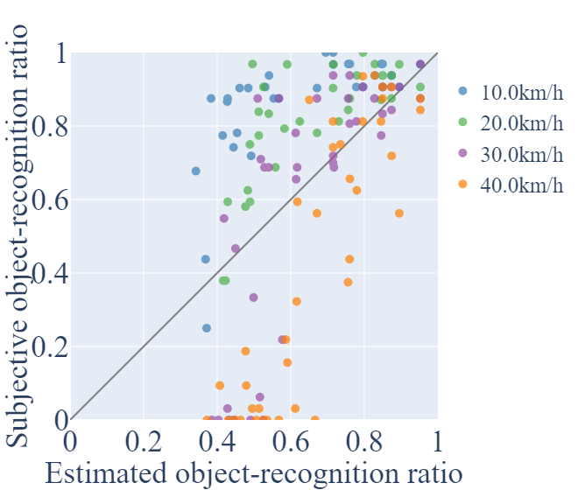  Figure 3: Performance of the model (Mode 0) without packet loss for each velocity | 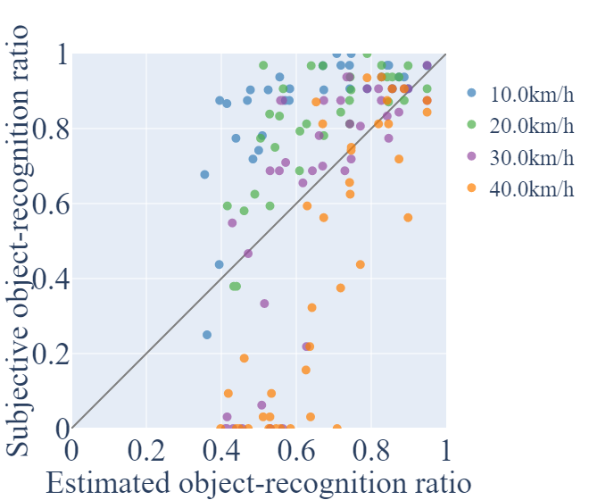  Figure 4: Performance of the model (Mode 1) without packet loss for each velocity

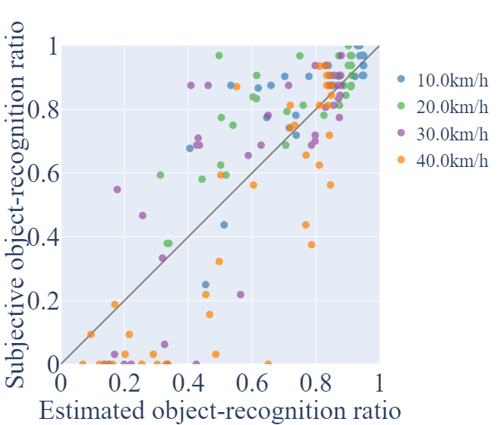  Figure 5: Performance of the model (Mode 2) without packet loss for each velocity | 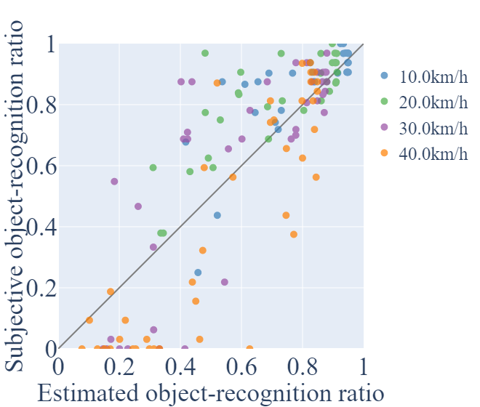  Figure 6: Performance of the model (Mode 3) without packet loss for each velocity

  - The Effect of Packet Loss on Estimation Accuracy
In this subsection, estimation accuracy for PVSs with and without packet loss is described. Figures 7 to 14 show scatter plots for the object-recognition ratios with and without packet loss. Table 9 shows RMSE and PCC of PVSs with and without packet loss.
These figures and tables show that PVS with packet loss have higher RMSE in modes 0 and 2 than in modes 1 and 3. In modes 0 and 2, only the packet loss ratio is inputted as packet loss information, but in modes 1 and 3, the frame loss ratio is also inputted. Even if the packet loss ratio is the same, the number of lost frames will differ depending on how many of the PVSs’ frames are lost. Since the effect of the frame loss of PVSs can be seen in more detail in modes 1 and 3, the estimation accuracy is higher in modes 1 and 3 than in modes 0 and 2 for PVSs with packet loss. On the other hand, even some PVSs without packet loss are also not estimated well in modes 1 and 3. The reasons for this are described in subsection 4.3.

Table 9: RMSE and PCC of the proposed model for each with and without packet loss
 |  | The number of PVSs | Mode 0 | Mode 1 | Mode 2 | Mode 3
RMSE | Without packet loss | 144 | 0.272 | 0.274 | 0.182 | 0.183
RMSE | With packet loss | 144 | 0.331 | 0.293 | 0.309 | 0.263
PCC | Without packet loss | 144 | 0.581 | 0.576 | 0.841 | 0.839
PCC | With packet loss | 144 | 0.502 | 0.642 | 0.588 | 0.729

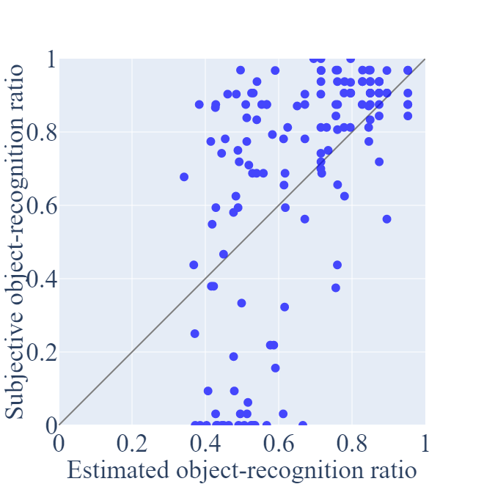  Figure 7: Performance of the model (Mode 0) without packet loss | 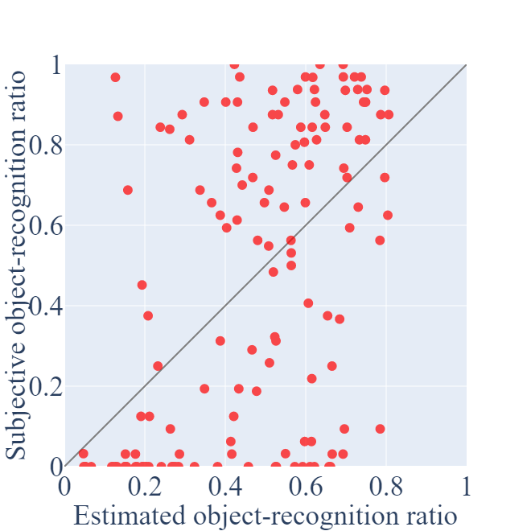  Figure 8: Performance of the model (Mode 0) with packet loss

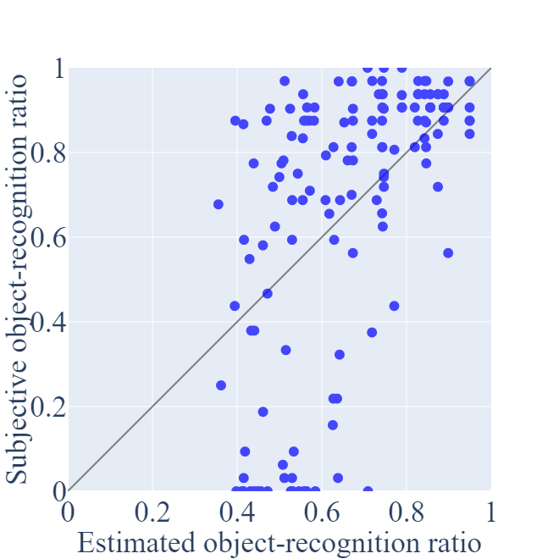  Figure 9: Performance of the model (Mode 1) without packet loss | 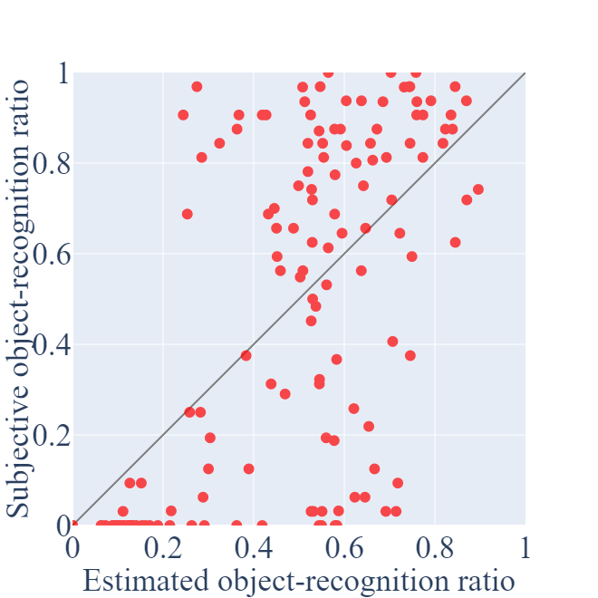  Figure 10: Performance of the model (Mode 1) with packet loss

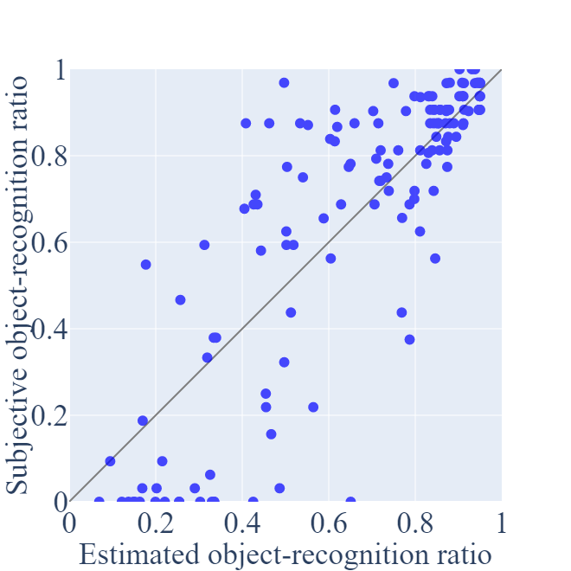  Figure 11: Performance of the model (Mode 2) without packet loss | 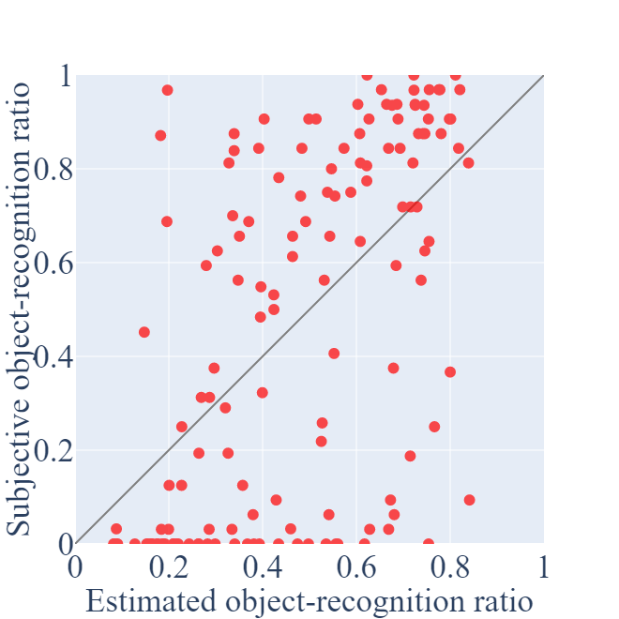  Figure 12: Performance of the model (Mode 2) with packet loss

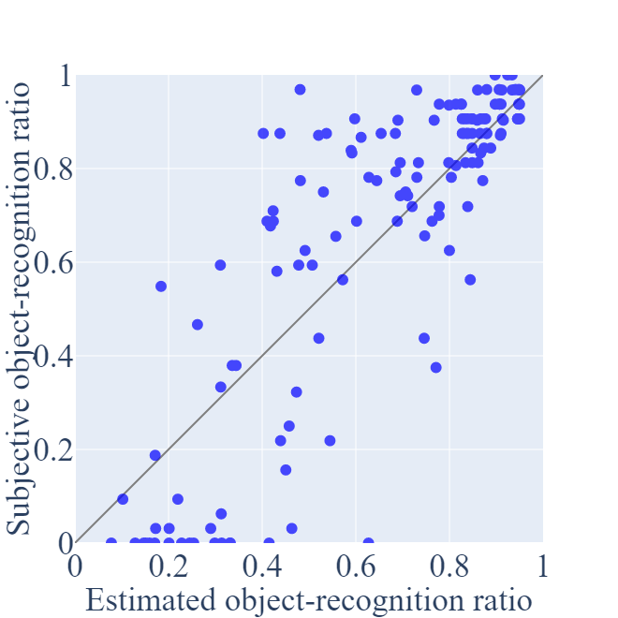  Figure 13: Performance of the model (Mode 3) without packet loss | 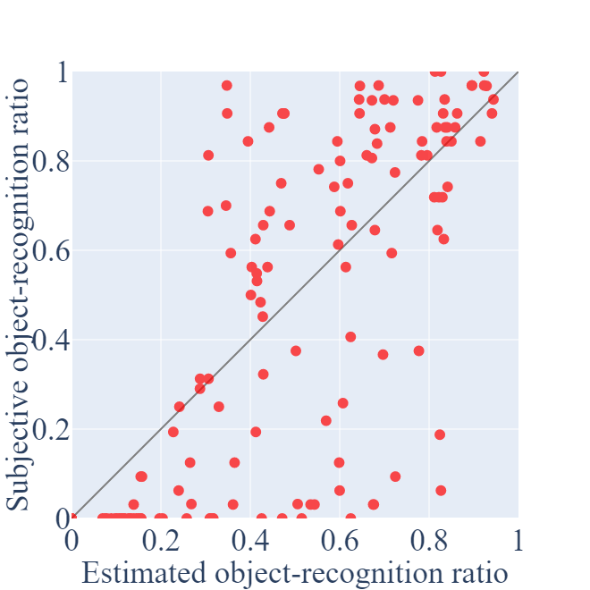  Figure 14: Performance of the model (Mode 3) with packet loss

  - Investigation into PVSs with Low Estimation Accuracy
The previous subsections showed that the velocity and packet loss affected the object-recognition ratio, and that the accuracy of the object-recognition ratio decreased. We checked the estimation accuracy individually, especially for PVSs where the estimation accuracy decreased significantly. Two factors were found to influence the estimation accuracy of the object-recognition ratio:
(i) the difference in visibility due to color contrast differences between the person and their backgrounds, and
(ii) the timing of packet loss occurring in the PVSs.
These factors of the estimation error are discussed in this section.

    - Color Contrast Differences between the Person and their Backgrounds
The decrease in estimation accuracy caused by color contrast differences is explained in detail along with specific examples of PVSs.

      - PVSs with High Color Contrast Difference between Person and Background
First, we investigated the causes of the accuracy decrease in the estimated object-recognition ratio for PVSs without packet loss. There are 24 PVSs without packet loss where the subjective object-recognition ratio is 30% higher than the estimated object-recognition ratio. These PVSs mainly have a high color contrast difference between the person and the background, making the person easier to recognize. Figure 15 shows an example thumbnail of a high-color contrast difference PVS. In this PVS, although the bitrate is low, the color contrast difference between the person and the background is high because the background is black. Since the proposed model is parametric and does not account for background color contrast differences behind the person, the subjective object-recognition ratio is higher than the estimated object-recognition ratio.
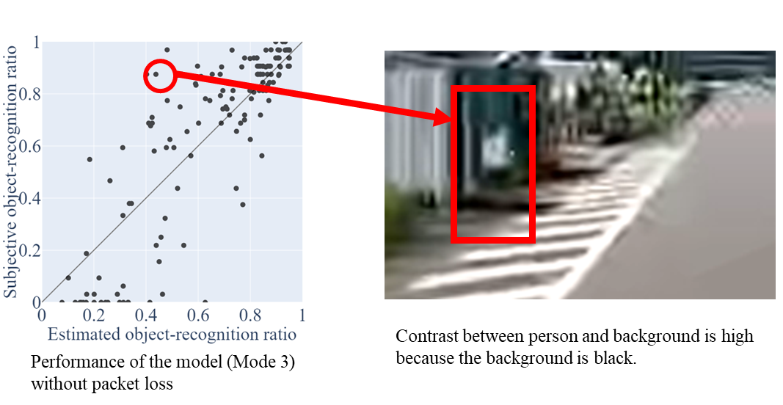
Figure 15: Example thumbnail of high color contrast difference PVS

      - PVSs with Low Color Contrast Difference between Person and Background
There are 12 PVSs without packet loss where the subjective object-recognition ratio is over 30% lower than the estimated object-recognition ratio. In contrast to the PVSs described in the previous subsection, these PVSs mainly have a low color contrast difference between the person and the background, making the person difficult to recognize. Figure 16 shows an example thumbnail of a low color contrast difference PVS. In this PVS, the color contrast difference between the person and the background is low since the building behind the person is white. Therefore, the estimated object-recognition ratio is higher than the subjective object-recognition ratio. In the proposed model, only the bitstream is input, and the media layer information is not used. Therefore, the proposed model can estimate a decrease in the average object-recognition ratio due to the decrease in bitrate. However, the impact of individual locations behind the person is difficult to take into account.

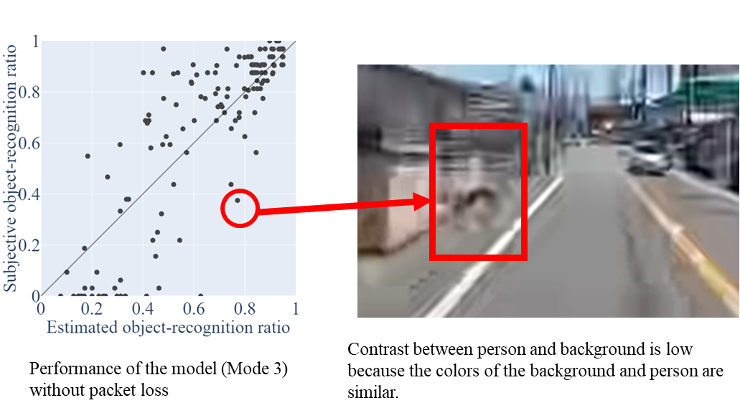
Figure 16: Example thumbnail of low color contrast difference PVS

    - Timing of the packet loss in the PVSs
The decrease in estimation accuracy caused by the timing of packet loss is explained in detail along with specific examples of PVSs.

      - The Packet Loss Occurs Intensively in the Second Half of the Person Appear
We investigated the causes of the decrease in accuracy of the estimated object-recognition ratio for PVSs in which packet loss occurs. In this model, the packet loss ratio is calculated as the packet loss percentage in one second from when a person appears in the PVS. Since the location of packet loss in this one second is not considered, the subjective object-recognition ratio differs depending on the location of packet loss in the one second. There are 8 PVSs with packet loss where the subjective object-recognition ratio is over 30% higher than the estimated object-recognition ratio. These PVSs have a large packet loss of the second half of the second. However, the person can be recognized in the first half of the second, so the subjective object-recognition ratio is high. Figure 17 shows an example thumbnail of a PVS with this pattern of packet loss. Since this PVS’s overall packet loss is large, the estimated object-recognition ratio is low. However, the subjective object-recognition ratio is high because the person can be recognized in the first half of the second. Therefore, the estimated error is increased.

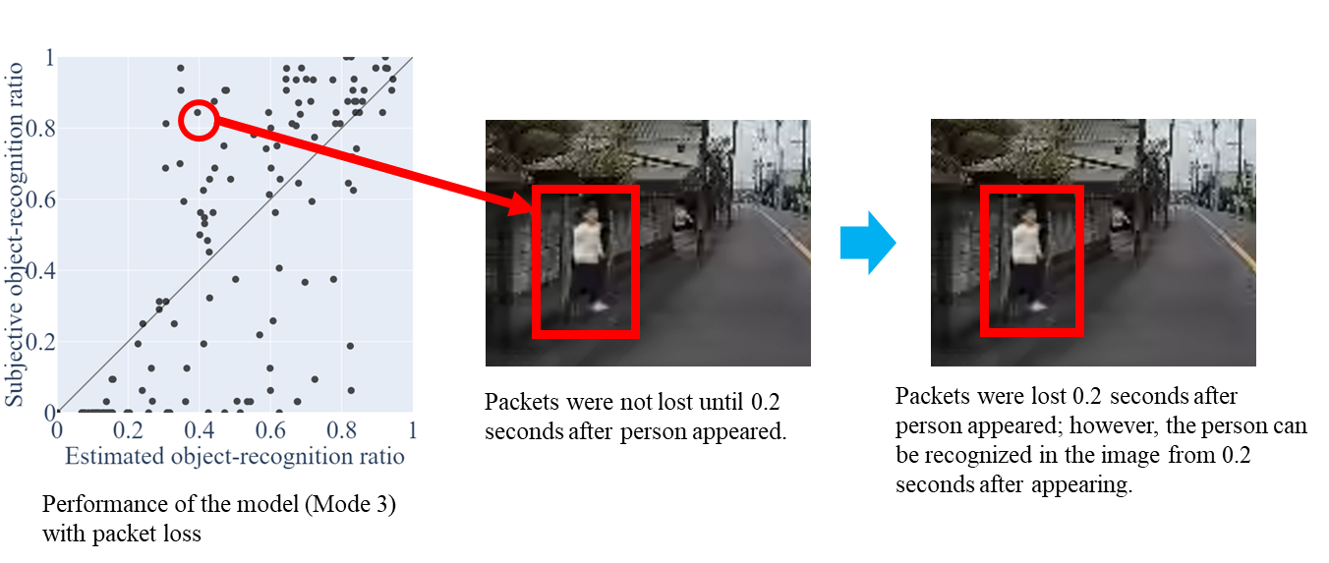
Figure 17: Example of PVSs where packet loss occurred intensively in the second half of the second in which the person appeared person appear

      - The Packet Loss Occurs Intensively in the First Half of the Second in which the Person Appears
In contrast to the PVSs in the previous subsubsection, there are 11 PVSs whose packet loss is concentrated in the first half of the second in which the person appears. Because these PVSs have a large packet loss in the first half of the second in which the person appears, the person cannot be recognized in the first half of the second. In the second half of the second, if packet loss does not occur, the person can be recognized. However, if participants have to recognize the person in the remaining short time (for example, within 0.6 seconds), the subjective object-recognition ratio will decrease. Figure 18 shows an example of a thumbnail of a PVS with this pattern of packet loss. Since this PVS’s packet loss is concentrated in the first half of the second, participants had difficulty recognizing the person in time. Therefore, in this PVS, the estimated object-recognition ratio is higher than the low subjective object-recognition ratio. This results in the estimated error increasing.
Since the proposed model does not take into account when the packet loss occurred in the first second in which the person appears, the accuracy of the estimation may differ depending on the position of the packet loss.

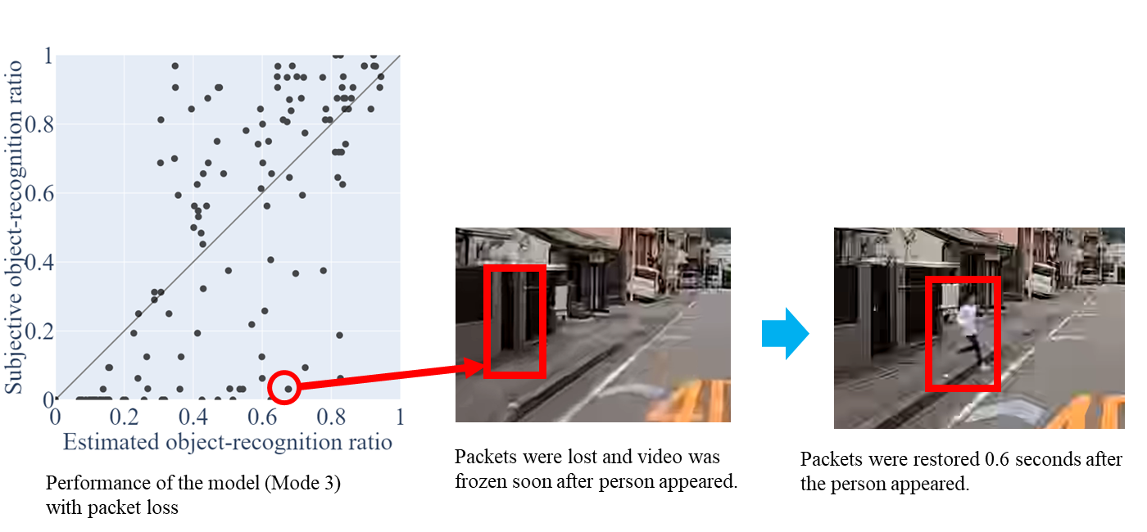
Figure 18: Example of PVSs where packet loss occurred intensively in the first half of the second in which the person appeared

    - Estimated Accuracy Excluding PVSs Affected by Color Contrast Difference of Background and Packet Loss
As described in the previous section, we found that the estimation accuracy of some PVSs decreased due to the color contrast difference of the background and the packet loss. To verify the estimation accuracy of the proposed model when these 51 PVSs are not present, the object-recognition ratio was calculated after excluding them. Figure 19 shows the results of the verification, and Table 10 shows the RMSE and PCC of these results. For comparison purposes, Table 11 presents the results obtained by excluding the impact of these factors on the object-recognition ratio degradation in H.265-encoded videos [7].
The results of these verifications show that the estimation accuracy was improved. Since this model does not use media information or details of packet loss information as input, these could not be taken into account. However, it was found that they could be estimated if they were excluded, and the same accuracy as that of H.265 encoded video was achieved.

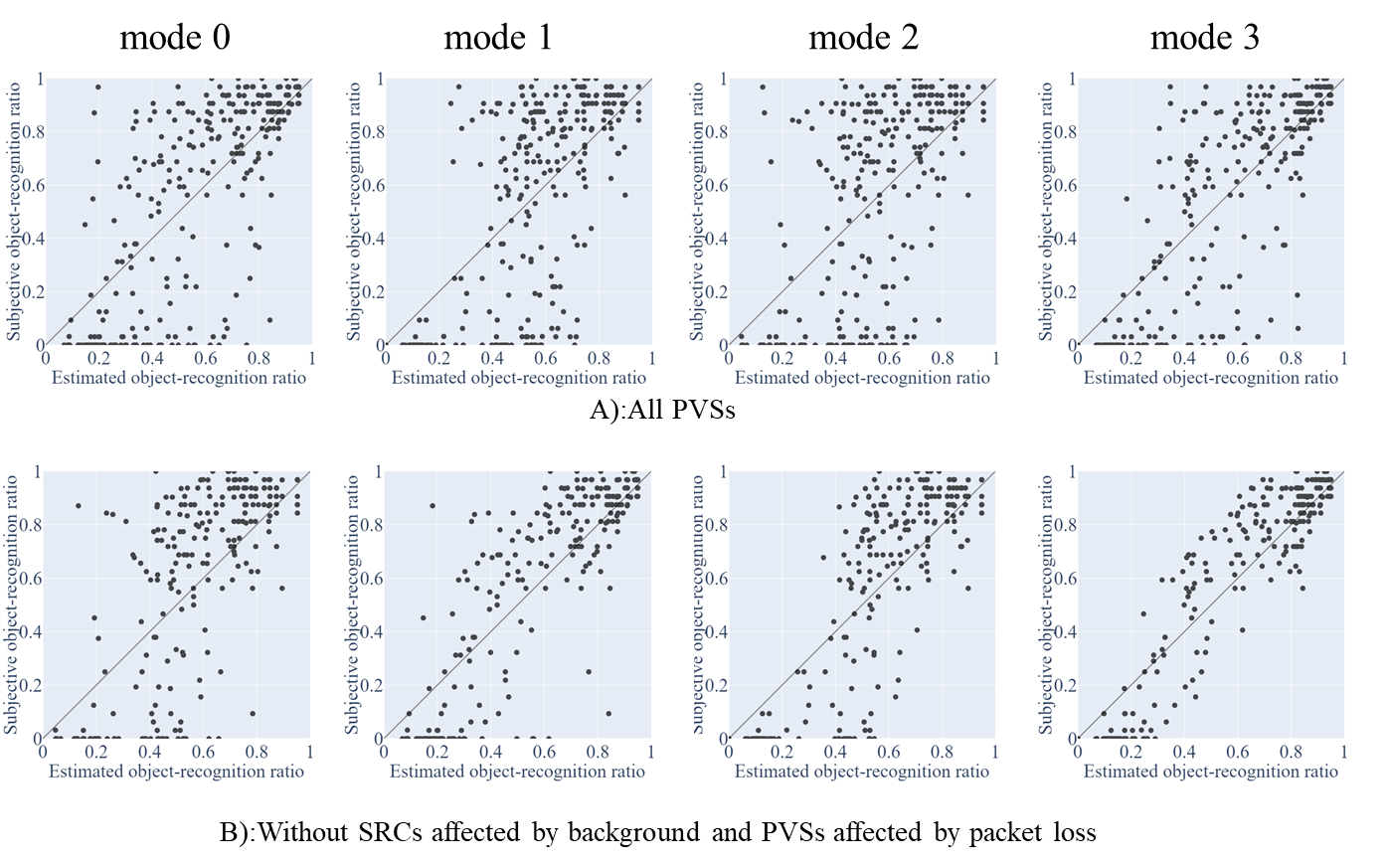
Figure 19: The performance of verification without specific PVSs

Table 10: RMSE and PCC of the proposed model without specific PVSs
 |  | The number of PVSs | Mode 0 | Mode 1 | Mode 2 | Mode 3
RMSE | All PVSs | 288 | 0.303 | 0.284 | 0.254 | 0.226
RMSE | Without SRCs affected by background and PVSs affected by packet loss | 237 | 0.258 | 0.217 | 0.197 | 0.136
PCC | All PVSs | 288 | 0.681 | 0.649 | 0.733 | 0.797
PCC | Without SRCs affected by background and PVSs affected by packet loss | 237 | 0.700 | 0.809 | 0.839 | 0.932

Table 11 RMSE and PCC of H.265 encoded model without specific PVSs
 |  | The number of PVSs | Mode 0 | Mode 1 | Mode 2 | Mode 3
RMSE | All PVSs | 296 | 0.254 | 0.247 | 0.212 | 0.204
RMSE | Without SRCs affected by background and PVSs affected by packet loss | 230 | 0.220 | 0.207 | 0.161 | 0.145
PCC | All PVSs | 296 | 0.547 | 0.583 | 0.715 | 0.743
PCC | Without SRCs affected by background and PVSs affected by packet loss | 230 | 0.577 | 0.641 | 0.803 | 0.850

- Proposals
In this contribution, the estimation results of the training experiment using AV1-encoded videos were presented. The results show that the estimation accuracy of AV1 is comparable to that of H.265, enabling the implementation of AV1 verification experiments and progress toward drafting P.1199. Furthermore, while estimation errors are large for some videos, they are similar to the results observed in H.265, and AV1 contains no new error factors. The result of the training data has been submitted, and we propose that we move to the validation phase. The validation results will be shown in May 2026 (e.g., SG12 interim meeting).

- References
[1] ITU-T SG12 (Study Period 2025-2028) Contribution 53, Extension of P.obj-recog to AV1 codec
[2] ITU-T SG12 (Study Period 2025-2028) Contribution 51, Draft Terms of Reference (ToR) P.obj-recog
[3] ITU-T SG12 (Study Period 2025-2028) Contribution 52, Draft Test plan for AV1 codec of P.obj-recog
[4] ITU-T SG12 (Study Period 2022-2024) Contribution 205, P.obj-recog experimental result
[5] ITU-T SG12, P.1401: Methods, metrics and procedures for statistical evaluation, qualification and comparison of objective quality prediction models, 2020
[6] ITU-T SG12 (Study Period 2025-2028) TD 220, P.obj-recog: Validation experiment results of IPP encoding
[7] ITU-T SG12 (Study Period 2025-2028) Contribution 7, Performance of proposed model for validation data

______________

Appendix I

P.1199 model Building Blocks
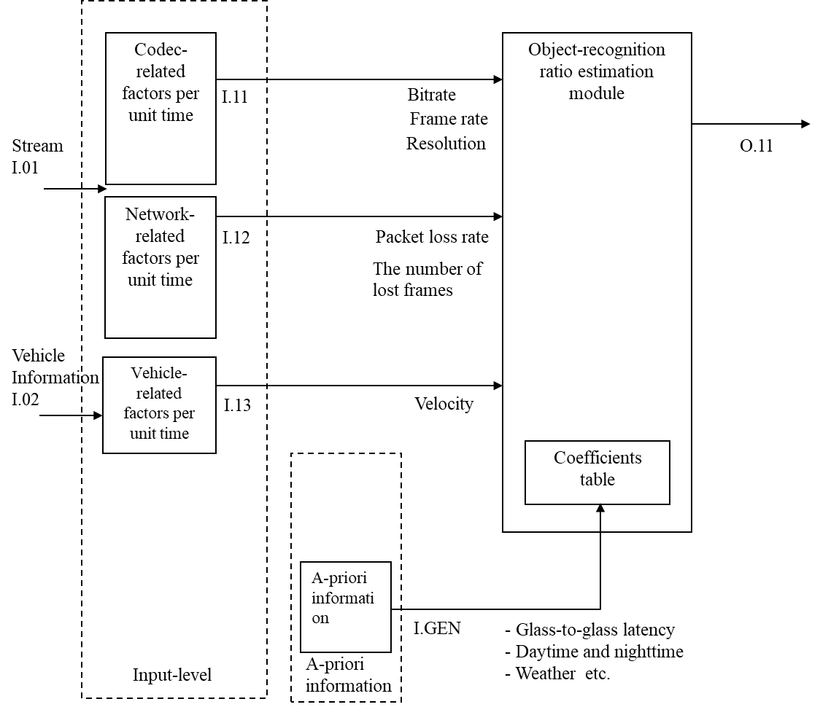
Figure I-1 shows the building blocks of the P.1199 model, and Table I.1 lists the operational modes. The model’s input parameters are shown in Figure I-1.

Figure I-1: Building blocks of the model

Table I.1: P.obj-recog modes of operation
Mode | Input
0 | Meta-data and packet loss information
1 | Meta-data and frozen video frame information
2 | Meta-data, packet loss information and autonomous vehicle’s velocity
3 | Meta-data, frozen video frame information, and autonomous vehicle’s velocity

The details of input parameters and output are as follows:

I.11: Codec-related factors
Video resolution (pels); video bitrate (kbps); video frame rate (fps) per unit time for all modes.

I.12: Network-related factors
- Video packet loss rate (%) per unit time for modes 0 and 2.
- The number of lost video frames (frames) per unit time for modes 1 and 3. Since the video frame loss pattern (e.g., random, burst) is not considered, the value of this factor becomes the same when the number of lost frames in one unit of time is the same, even if the frame loss patterns are different, as shown in Figure 2.
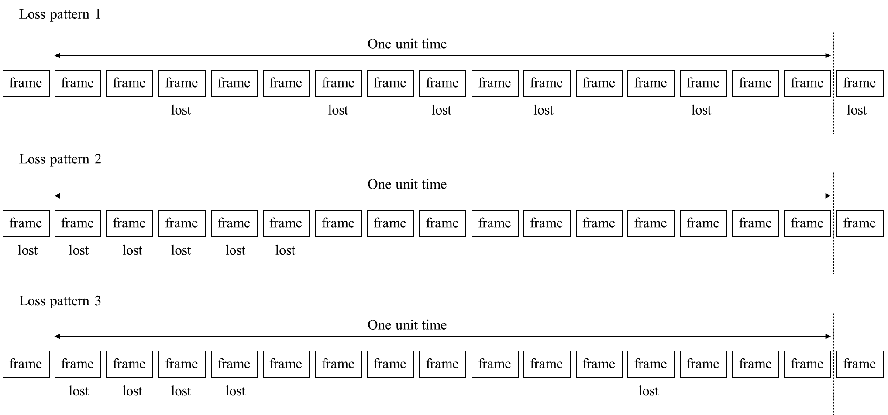
Figure 20: Example loss pattern where the number of lost video frames per unit time is 5

I.13: Vehicle-related factors
Autonomous vehicle’s velocity (km/h) per unit time. Note that this factor is used for modes 2 and 3.

I.GEN: A priori information for estimation module
A priori information for the estimation module includes the following:
- Packet-loss error concealment
  - Freezing with skipping
  - Block noise
- Codec
  - Codec
  - Profile
  - GOP
- Source-related factors
  - Object color
  - Object pixel size on screen at a specific distance
  - Object background
  - Weather
  - Daytime and nighttime
- Network latency factors
  - Glass-to-glass latency
  - Control latency
- Camera-related factors
  - Camera mode
  - Focal length
  - Field of view
  - Image stabilization
  - Auto white balance delay
  - Lens flare
- Reaction time factors
  - Required reaction time
- Road-related factors
  - Road surface coefficient of friction (This is determined on the basis of weather)

O.11: Output object-recognition ratio
This model outputs the object-recognition ratio. The object-recognition ratio is defined as the percentage of observers who can recognize objects within the time it is possible to prevent the vehicle from colliding with objects when these objects appear a target distance away from the autonomous vehicle.

Appendix II

Calculation of target distance
In estimating the object recognition ratio, several delays need to be considered. Figure II-1II-1 shows the workflow of events from the observer at the monitoring center recognizing objects in a surveillance video to the stopping of an autonomous car.
The surveillance video is encoded and sent to the monitoring center via a radio access network. Therefore, there are delays associated with encoding and network latency. In addition, there is a decoding and display latency until the video is displayed on the display. The sum of these delays is called glass-to-glass latency ($L_{G2G}$), which is defined in a-priori information.
Required reaction time ($L_{reaction}$) is the time between an observer recognizing an object and sending a brake command to an autonomous car, which is defined in a-priori information. This time relates to the observer’s ability, such as viewing angle or contrast sensitivity. $L_{reaction}$ depends on how much time the designer of the autonomous driving system gives the observer to recognize the object. In general, an observer takes at least 0.5 seconds to react to an object, so this required reaction time must be considered at this point.
Control latency ($L_{control}$) is the time between an observer sending a brake command and the autonomous car really starting to stop, which is defined in a-priori information. The sum of glass-to-glass latency, required reaction time and control latency is defined as total latency ($L_{total}$) in seconds, and this is given in the following equation.

$$L_{total}=L_{G2G}+L_{reaction}+L_{control}$$

The brake distance ($D_{break}$) in meters is given in the following equation using the autonomous car’s velocity $V$ km/h and coefficient of friction $μ$ ($μ$ is the parameter depending on weather). In modes 0 and 2 where the autonomous car’s velocity cannot be used, V is set to 40 (Max value in Table 1) considering the safety side.
$$D_{break}= \frac{V^{2}}{254μ}$$

Therefore, the target distance X in meters is given in the following equation.

$$X=\frac{VL_{total}}{3.6}+D_{break}$$
The recognition ratio is the percentage of observers who can recognize objects and send brake commands within the time it is possible to properly avoid a collision after the objects appear in the surveillance video at the target distance from the autonomous car.
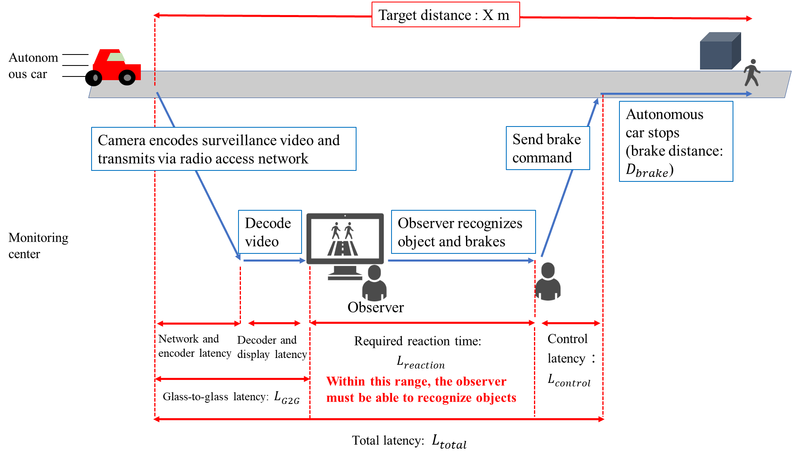
Figure II-1 The workflow of events from the observer at the monitoring center recognizing objects in a surveillance video to the stopping of an autonomous car

