 |  | INTERNATIONAL TELECOMMUNICATION UNION  TELECOMMUNICATION  STANDARDIZATION SECTOR  STUDY PERIOD 2025-2028 |  |  |  | SG12–C0002
 |  |  |  |  |  | STUDY GROUP 12
 |  |  |  |  |  | Original: English
 | Question(s): |  |  | 19/12 |  | Menlo Park, California, 7-8 May 2025​​
 | CONTRIBUTION
 | Source: |  |  | NTT
 | Title: |  |  | Validation experiment result of IPP encoding
Contact: |  |  | Masanori Koike  Japan  NTT |  | Tel: +81-422-59-4453  E-mail: masanori.koike@ntt.com
Contact: |  |  | Kazuhisa Yamagishi  Japan  NTT |  | Tel: +81-422-59-4397  E-mail: kazuhisa.yamagishi@ntt.com
Contact: |  |  | Noritsugu Egi  Japan  NTT |  | Tel: +81-422-59-4008  E-mail: noritsugu.egi@ntt.com
Contact: |  |  | Yoichi Matsuo  Japan  NTT |  | Tel: +81-422-59-4519  E-mail: yoichi.matsuo@ntt.com
Contact: |  |  | Masahiro Yokota  Japan  NTT |  | Tel: +81-422-59-2444  E-mail: masahiro.yokota@ntt.com

Abstract: | The validation results of the parametric object-recognition-ratio-estimation model were submitted to ITU-T SG12 in January 2025. Since the parametric object-recognition-ratio-estimation model has four modes depending on the input of the model, a significance test for RMSE was performed between a bitrate-based baseline model and the model of each mode. The results showed significant differences between a bitrate-based baseline model and the model of each mode. However, significant differences were not found between modes 0 and 1 or modes 2 and 3. Note that modes 0 and 2 use the packet loss rate, while modes 1 and 3 use the frame loss rate.  The reason no significant differences were observed between modes is presumed to be the high correlation between the packet loss rate and frame loss rate when using all-intra as the encoding mode. Therefore, we verified whether the same results could be obtained with video using the IPP structure, which is commonly used. Results showed that the correlation between packet loss rate and frame loss rate is low in video using the IPP structure, and significant differences can be found between modes.

Introduction
The validation results of the parametric object-recognition-ratio-estimation model were submitted to ITU-T SG12 in January 2025 [1]. The results showed significant differences between a bitrate-based baseline model and the model of each mode. However, significant differences were not found between modes 0 and 1 or modes 2 and 3. The difference between modes 0 and 1 as well as modes 2 and 3 depends on the input of the model, where the packet loss rate is inputted to the model in modes 0 and 2, while the number of lost frames is inputted to the model in modes 1 and 3.
The videos of the validation experiment were made by all-intra encoding. The reason no significant differences were observed between modes is presumed to the high correlation between the packet loss rate and frame loss rate in all-intra encoding, because the packet loss location corresponds to the frame loss location. However, when using the model in real use cases, the model may be used in other encoding conditions (e.g., IPP encoding). In IPP encoding, the frame loss will propagate to the subsequent frames. However, the models of modes 0 and 2 cannot use the frame loss rate, and the effect of loss frame propagation cannot be considered. Therefore, if the validation experiment with video using the IPP structure were conducted, the estimation results may differ between modes. To confirm estimation results obtained with video using the IPP structure, we also verified the model for videos using the IPP structure. The results of the validation experiment for videos using the IPP structure show significant differences between the bitrate-based baseline model and each mode, and significant differences can be found between modes 0 and 1, as well as modes 2 and 3. Therefore, recommendations need to be made for all modes in order to support various encoding methods.

- Summary of the All-intra Encoding Validation Experiment
In the all-intra encoding validation experiment, the results show that no significant differences were found between modes 0 and 1, or modes 2 and 3. This section presents the results of the all-intra encoding experiment and the reasons no significant differences were observed. Also, these experiments are conducted in all-intra encoding, but since IPP encoding is used in real use cases to improve encoding efficiency, each mode of the model has to be confirmed by IPP encoding. When applying each mode of the model to the IPP encoding, a hypothesis that should be considered is shown in this section.
The results of all-intra encoding validation experiments of root mean squared error (RMSE) and Pearson correlation coefficients (PCC) are shown in Tables 1 and 2. These results are the same as those shown in the previous meeting [1]. The results of the statistical test between the baseline model and models of each mode are shown in Table 3. The method of the statistical test is described in Section 7.8 of P.1401 [4]. In the statistical test, if the $t_{v}>0$, the proposed model and baseline model differ statistically significantly. This table shows that the proposed model is statistically significantly better than the baseline model. The results of the statistical test between modes are shown in Table 4. This table shows that the differences between modes 1 and 2 are significant, but the differences between modes 0 and 1, as well as modes 2 and 3 are not.

Table 1: RMSE and PCC of the proposed model for daytime
 | Baseline model | Mode 0 | Mode 1 | Mode 2 | Mode 3
RMSE | 0.298 | 0.254 | 0.247 | 0.212 | 0.204
PCC | 0.122 | 0.547 | 0.583 | 0.715 | 0.743

Table 2: RMSE and PCC of the proposed model for nighttime
 | Baseline model | Mode 0 | Mode 1 | Mode 2 | Mode 3
RMSE | 0.315 | 0.216 | 0.201 | 0.176 | 0.164
PCC | 0.129 | 0.687 | 0.741 | 0.819 | 0.861

Table 3: Results of the statistical test between the baseline model and models for each mode
Modes | $t_{v}$: Daytime | $t_{v}$: Nighttime
Mode 0 | 0.165 | 0.915
Mode 1 | 0.244 | 1.244
Mode 2 | 0.764 | 1.991
Mode 3 | 0.922 | 2.346

Table 4: Results of the statistical test between modes
Modes | $t_{v}$: Daytime | $t_{v}$: Nighttime
Mode 0 and 1 | 0 | 0
Mode 1 and 2 | 0.146 | 0.0924
Mode 2 and 3 | 0 | 0

The difference between modes 0 and 1, and modes 2 and 3 is the input of the network-related factor. The packet loss rate is inputted to the parametric object-recognition-ratio estimation model in modes 0 and 2. In contrast, the number of lost frames is inputted to the model in modes 1 and 3. As the video bitrate increases, the number of packets that make a frame increases. In modes 0 and 2, if multiple packets are lost, frame loss is calculated by packet loss as if multiple packets were lost probabilistically. On the other hand, in modes 1 and 3, the accurate frame loss rate can be used, and the estimation performance will be higher than in modes 0 and 2. However, in the validation experiment, the performance differences between modes 0 and 1, and modes 2 and 3 are not significant.

  - Reasons for No Significant Difference Between Modes 0 and 1, or Modes 2 and 3
The reason there is no significant difference is considered to be the strong correlation between packet loss and the number of lost frames. In all-intra encoding, when one packet is lost, only the corresponding frame will be lost. Figure 1 shows an example of a relationship between packet loss and frame loss in all-intra encoding. This figure shows a high correlation between packet loss and frame loss because the packet loss location corresponds to the frame loss location. It is considered that the same tendency exists in the videos of the all-intra validation experiment. If there is a strong correlation between packet loss rate and frame loss rate in the validation experiment, the frame loss can be estimated accurately by using the packet loss rate, and the estimation accuracy of modes 0 and 2 are improved. Therefore, it is considered that no significant difference was found in modes 0 and 1, or modes 2 and 3.

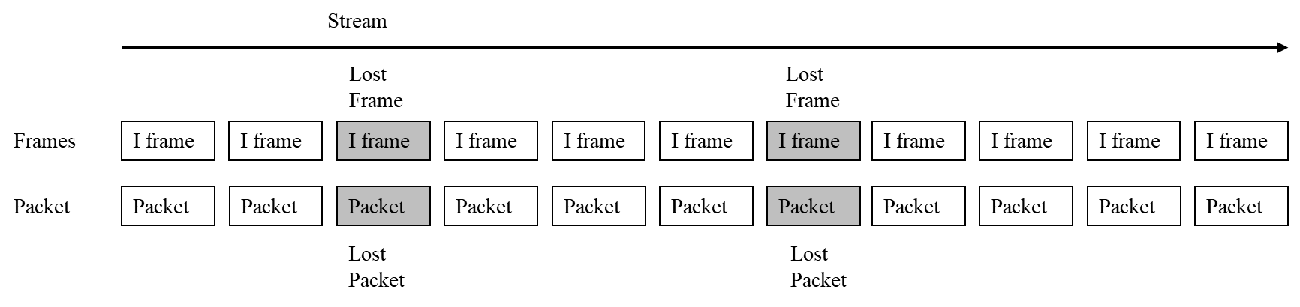
Figure 1: The example of a relationship between packet loss and frame loss in all-intra encoding

- Hypothesis for Applying Each Model of the Model to IPP Encoding
In IPP encoding, the frame loss will propagate to the subsequent frames. Figure 2 shows two examples of a relationship between packet loss and frame loss in IPP encoding. They are two examples of losing one packet, but the number of lost frames is different. If the processed video sequences (PVSs) are IPP encoded, a statistically significant difference may occur between modes 0 and 1, as well as modes 2 and 3 because it is difficult to estimate lost frame rate by packet loss rate accurately.

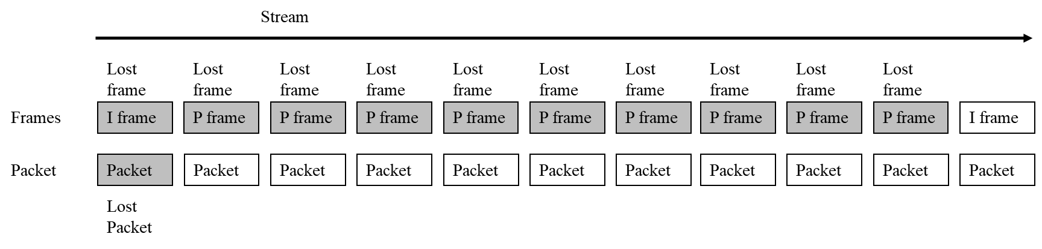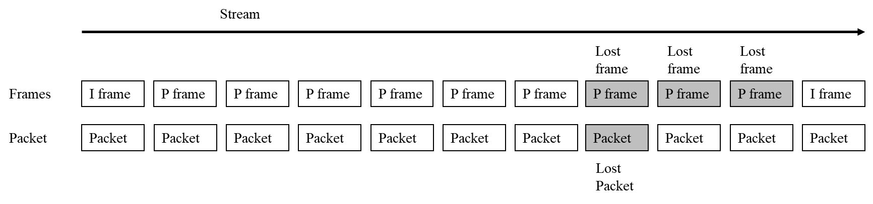
Figure 2: Example of a relationship between packet loss and frame loss in IPP encoding

- Subjective Experiment

To check whether there is a significant difference between modes 0 and 1 as well as modes 2 and 3, an additional experiment is conducted using IPP encoding.
  - Source Reference Circuits (SRC)
To obtain the result of the object-recognition ratio, subjective experiments of training and validation were conducted in accordance with the ToR [2] and Test plan [3]. Eighty daytime source videos, also called source reference circuits (SRCs), were obtained by a surveillance camera on the front of a car. The numbers of SRCs by velocity are listed in Table 5. All SRCs last 25 to 35 seconds and show a person darting out into a road from behind a building around 20 to 30 seconds into the video. The videos encoded from these SRCs were used to calculate the object-recognition ratio. Additionally, we prepared 8 SRCs for daytime data to prevent the participants from getting used to the appearance of the person darting out. No person darted out into the road in 6 SRCs, and other objects (i.e., traffic cones) are shown in the other 4 SRCs. These 10 SRCs were not used for calculating the object-recognition ratio because no humans are displayed.
The resolution of the source video was 1920 x 1080/59.94 fps (Chroma sampling: 4:2:0). The SRCs had four car-velocity patterns: 10, 20, 30, and 40 km/h. Examples of thumbnails are shown in Figure 3. The SRCs have no audio.

Table 5: The number of SRCs by velocity
 | Velocity (km/h)
 | 10 | 20 |  | 30 | 40
The number of SRCs (training) | 20 videos | 20 videos |  | 20 videos | 20 videos
The number of SRCs (validation) | 20 videos | 20 videos |  | 20 videos | 20 videos
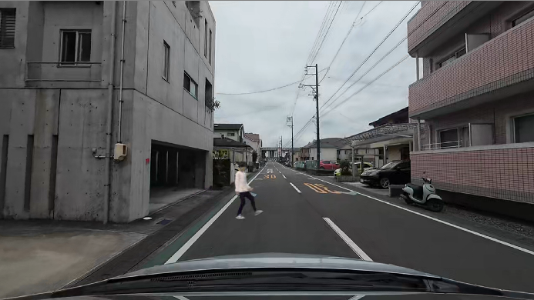  700 kbps, 15fps, 10km/h |  |  | 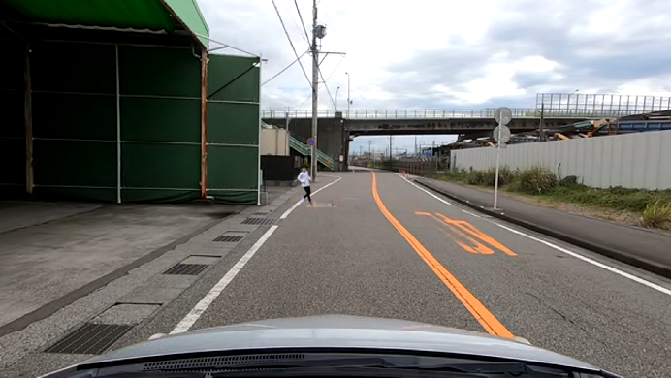  5000kbps, 60fps, 30km/h
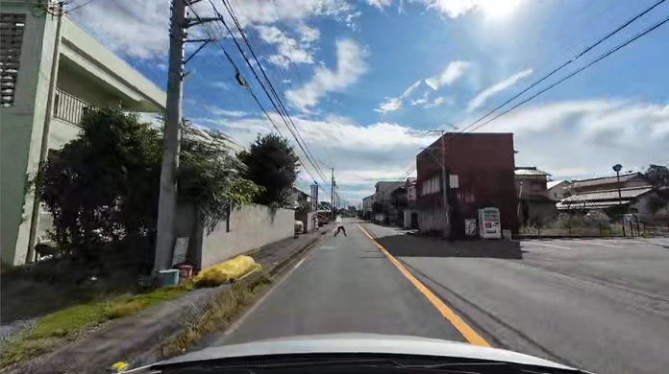  900kbps, 30fps, 30km/h |  |  | 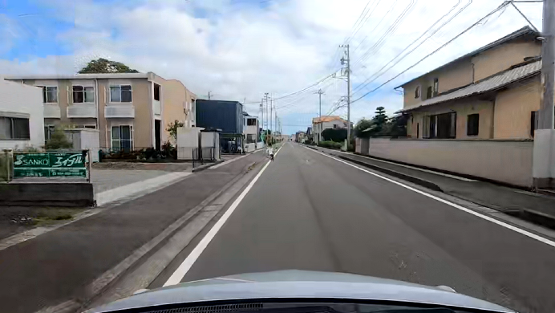  500kbps, 15fps, 40km/h
Figure 3: Examples of thumbnails

  - Hypothetical Reference Circuits (HRC)
Experimental conditions, also called hypothetical reference circuits (HRCs), are described in this subsection. SRCs were encoded by FFmpeg encoder v4.0, H.265/high-efficiency video coding (HEVC) (GOP: 1 second, IPP). There were several bitrate, resolution, framerate, velocity, and packet-loss patterns, as detailed in Table 6. For packet-loss concealment, a frozen video frame is used, i.e., when packet loss occurs, the video frames are frozen (i.e., no block distortion due to packet loss is shown). Note that the measured values of video bitrate and packet loss were different from the set values. Therefore, the measured bitrate and packet loss are used to estimate the object-recognition ratio.

Table 6: Setting values
Quality factors | Parameter setting (training) | Parameter setting (validation)
Bitrate (kbps) | 50 – 5000,  40000 (for reference) | 50 – 5000,  40000 (for reference)
Resolution | 640 x 360, 960 x 540,  1280 x 720, 1920 x 1080 | 640 x 360, 960 x 540,  1280 x 720, 1920 x 1080
Framerate (fps) | 10, 15, 30, 60 | 10, 15, 30, 60
Velocity (km/h) | 10, 20, 30, 40 | 10, 20, 30, 40
Packet loss rate | 0,3,5,7,10% | 0,1,2,3,4,5,6,7,8,9,10%

  - Processed Video Sequences (PVSs)
The PVSs were generated as follows. First, each SRC was encoded at a specific setting on the basis of HRC using FFmpeg. Next, an encoded video was packetized and delivered using FFmpeg. Then, Wireshark captured the delivered packets. After capturing the delivered packets, lost packets are determined in accordance with a set packet-loss rate, and packets determined to be lost were removed. The video frames containing the lost packets or P-frames with lost referenced frames were frozen.
In both of training and validation experiment, 72 SRCs were encoded in four patterns (288 PVSs), and the remaining 8 SRCs were used by the anchor. In total, 296 daytime PVSs were created. In this experiment, participants were divided into four groups, and participants in each group were assigned to watch a different PVS so that each PVS was watched by 32 participants.
  - Subjective Experiment Procedures
Before the subjective experiment, participants read the instructions to understand the procedure and the object of the experiment. They also took visual acuity and color vision tests. Then, participants moved on to the training test. In the training test, participants watched 10 PVSs in 1 session that lasted about 5 minutes. After the training session, participants moved on to the main test. During the main test, participants watched 10 PVSs in 1 session the same as in the training test, and they did 9 sessions (i.e., participants watched 90 PVSs). There were 2-minute breaks between sessions and 10-minute breaks every 2 sessions. The whole experiment lasted about 150 minutes, including visual acuity and color vision tests, instruction, tests, and breaks.
The participants monitored the video using special software for object recognition. When the participants saw that a person had stepped onto the sidewalk or objects were placed on the road, they clicked the mouse and the video stopped. Their reaction time was measured. After clicking the mouse, a screen for moving to next video was displayed, and the next video was started by clicking on the screen. The details of the test procedure are given in the Test Plan [3].

  - Subjective Experiment Participants
Both the training and validation experiments were conducted by 128 participants (training: 65 males and 63 females ranging from 18 to 47 years old, the average age is 22.4, and validation: 68 males and 60 females ranging from 18 to 42 years old, the average age is 21.7) who had passed the visual acuity and color vision tests.

  - Derivation of Object-Recognition Ratio
The object-recognition ratio is the percentage of participants who can recognize objects in the surveillance video and click the mouse within the time it is possible to avoid a collision after the objects appear at the target distance from the autonomous car. The details of the calculation of the object-recognition ratio are described in Section 3.5 of the Test Plan [3]. In this experiment, the required reaction time is set to one second. Therefore, if the participants can recognize and click the mouse within one second, it is judged that the object can be recognized. Note that the timing of the I frame is randomly set in the one second where the object appears.

- Experimental Results
  - Screening of Participants
In this experiment, before analyzing the object-recognition ratio data, participants were screened in the same way as in the previous validation experiment [1]. Since the participants with low correlation coefficients had low object-recognition ratios for overall object recognition, they were considered inappropriate for evaluation. In this experiment, the participants with a correlation coefficient of 0.5 or lower were screened out, and four of 128 participants in the training experiment and two of 128 participants in the validation experiment were screened out of this experiment.
  - Correction of Validation Data by Anchor PVSs
The same as in the previous validation experiment [1], we compared the tendencies of participants’ object-recognition ratio between training and validation PVSs, and the anchor data in the validation data was compared with that of training data. The anchor PVSs have to be compensated by a linear mapping function as follows.
$R_{anchor_training_i}=c_{1}*R_{anchor_validation_i}+c_{2}$,
where $c_{1}$and $c_{2}$ are coefficients, $R_{anchor_validation_i}$ is the object-recognition ratio of the ith anchor PVSs of validation data, and $R_{anchor_training_i}$ is the object-recognition ratio of the ith anchor PVSs of training data. The coefficients are shown in Table 7.
Table 7: Coefficients for correction by anchor
Coefficients | Value
$$c_{1}$$ | 1.02677
$$c_{2}$$ | -0.01627
By using the coefficients obtained by the mapping function above, all validation PVSs are corrected using the following equation,
$R_{corrected_validation_j}=c_{1}*R_{validation_j}+c_{2}$,
where $R_{corrected_validation_j}$ is the object-recognition ratio of jth PVSs of validation data after correction and $R_{validation_j}$ is the object-recognition ratio of jth PVSs of validation data before correction. Then, $R_{corrected_validation_j}$ is cropped 0 if the $R_{corrected_validation_j}$ is under 0. The performance of the proposed model is calculated by the corrected validation object-recognition ratio.
  - Performance of Proposed Model
By using the subjective object-recognition ratio, the proposed model was validated on 296 PVSs. Scatter plots of the results are shown in Figure 4. In these figures, the horizontal and vertical axes show the estimated and subjective object-recognition ratios (referred to as Estimated Ratio and Subjective Ratio), respectively. The RMSE and PCC are also shown in Table 8. The RMSE and PCC are rounded off to three decimal places.

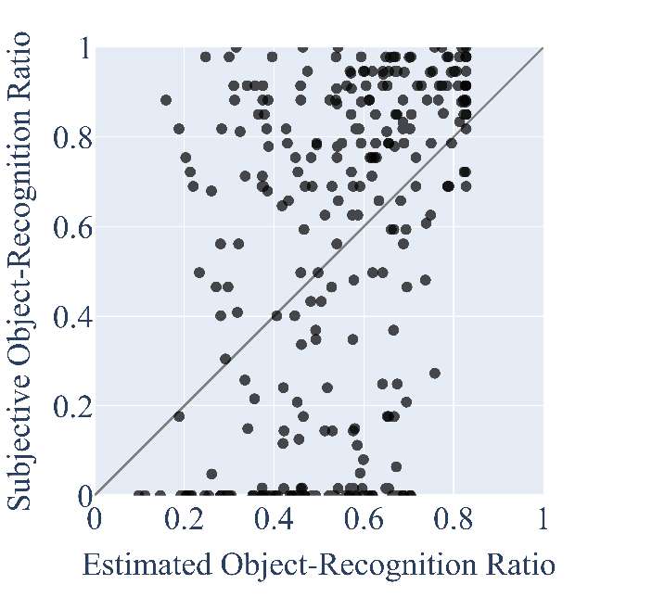  a) mode 0 | 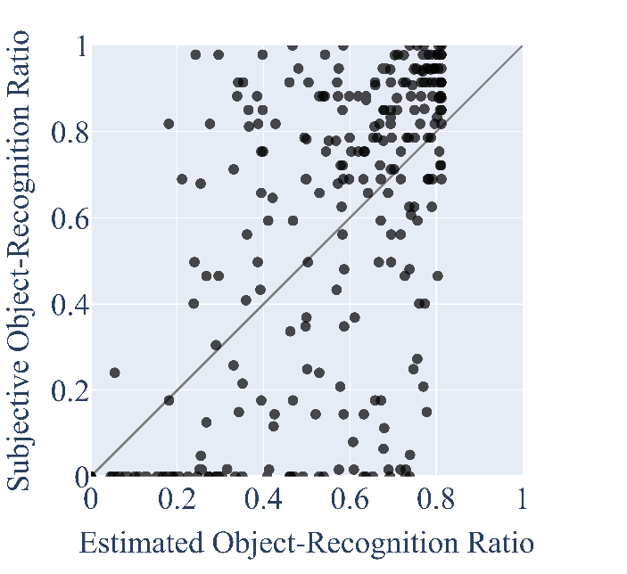  b) mode 1
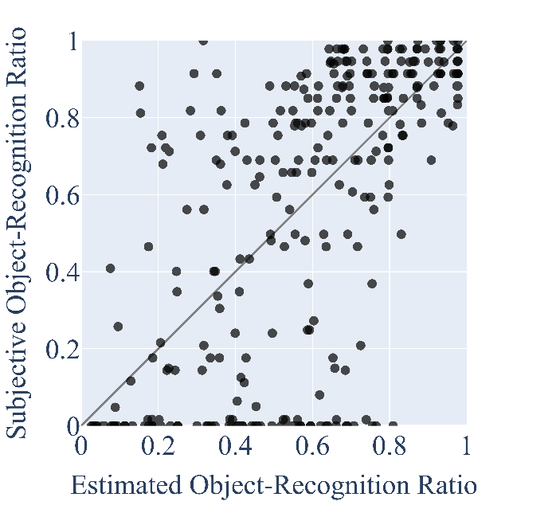  c) mode 2 | 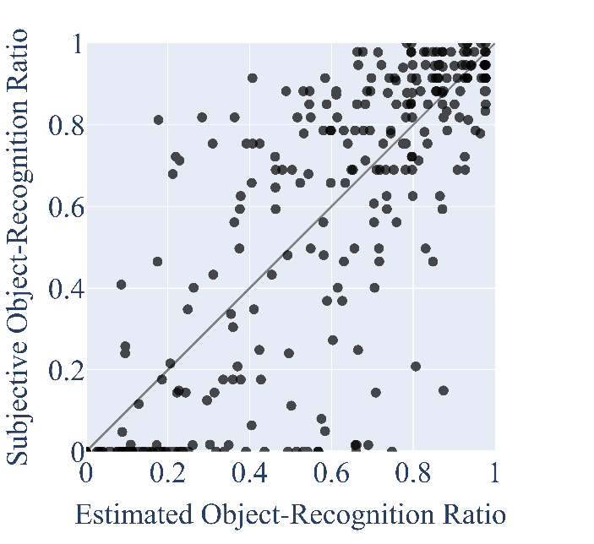  d) mode 3
Figure 4: Performance of the model

Table 8: RMSE and PCC of proposed model
 | Mode 0 | Mode 1 | Mode 2 | Mode 3
RMSE | 0.341 | 0.292 | 0.295 | 0.231
PCC | 0.434 | 0.636 | 0.633 | 0.795

  - Performance of Baseline Model
The performance of the baseline model is described in this subsection. The baseline model was the minimum requirement for the overall model performance. On the basis of the validation procedure, the baseline model is computed using a simple mapping of the second-order bitrate to the subjective object-recognition ratio. Specifically, the object-recognition ratio $R_{baseline}$ predicted by the baseline model is
$R_{baseline}=c_{1}*b^{2}+c_{2}*b+c_{3}$,
where $b$ is the bitrate of PVS in the validation test and the parameters $c_{1}-c_{3}$ are coefficients determined using the training dataset. The determined coefficients and estimation results of the baseline model are shown in Table 9, and the RMSE and PCC of the baseline model are shown in Table 10.

Table 9: Coefficients for the baseline model
Coefficients | Value
$$c_{1}$$ | $$\text{-}\text{5}\text{.}\text{40710}\text{*}{\text{10}}^{\text{-10}}$$
$$c_{2}$$ | $$\text{3}\text{.}\text{19526}\text{*}{\text{10}}^{\text{-5}}$$
$$c_{3}$$ | 0.46545

Table 10: RMSE and PCC of the baseline model
 | Daytime
RMSE | 0.404
PCC | 0.173

  - Statistical Evaluation of Proposed Model and Baseline Model, and Between Modes of Proposed Model
In this subsection, the comparison between the proposed and baseline models and between modes, are described. The validation procedures specify to use the statistical test described in Section 7.8 of P.1401 [4]. On the basis of that, we checked whether the submitted model was superior to the baseline model. In the validation procedure, if the $t_{v}>0$, the proposed model and baseline model are statistically different. The results of the statistical test between the baseline model and models of each mode are shown in Table 11. This table shows that the proposed model is statistically significantly better than the baseline model for all modes. The results of the statistical test between modes are shown in Table 12, and there are statistically significant differences between modes 0 and 1 as well as modes 2 and 3. The factor of statistical difference is shown in the following section. However, there are no statistically significant difference between modes 1 and 2. In mode 1, frame loss information is inputted to the model, while in mode 2, the vehicle’s velocity information is inputted. In the results of this verification experiments, both of these inputs were important, and the estimation accuracy was almost the same in both mode 1 and mode 2.

Table 11: Results of the statistical test between the baseline model and models for each mode
Modes | $t_{v}$: Daytime
Mode 0 | 0.192
Mode 1 | 0.702
Mode 2 | 0.664
Mode 3 | 1.212

Table 12: Results of the statistical test between modes
Modes | $t_{v}$: Daytime
Modes 0 and 1 | 0.152
Modes 1 and 2 | 0
Modes 2 and 3 | 0.419

- The Factor of Estimation Accuracy Difference Between Modes 2 and 3
We found statistically significant differences between modes 0 and 1 as well as modes 2 and 3 by using IPP encoding. The correlation coefficients are checked to compare the correlation between the packet loss rate and frame loss rate of all-intra and IPP encoding. Figure 5 shows the relationship between packet loss rate and frame loss rate (value of the number of lost frames divided by frame rate) of all-intra encoding PVSs, and Figure 6 shows that of IPP encoding PVSs. Table 13 shows the PCCs of all-intra encoding and IPP encoding. In all-intra encoding, there is a relationship between packet loss rate and frame loss rate, and the frame loss can be estimated by the packet loss rate, and the estimation accuracy of modes 0 and 2 is improved. On the other hand, in IPP encoding, the frame loss will propagate to the subsequent frames. However, the models of modes 0 and 2 cannot use the frame loss rate so the effect of loss frame propagation cannot be considered. Therefore, the effect of frame loss is difficult to determine, and the estimation accuracy will decrease compared to mode 3.

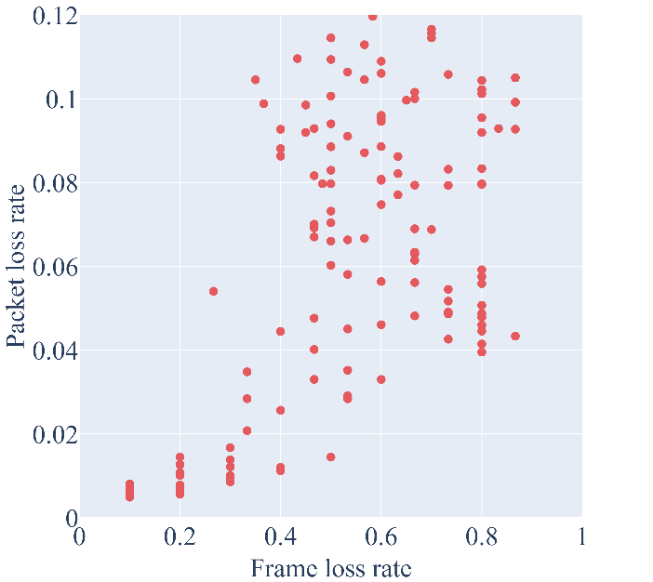  Figure 5: Packet loss rate and frame loss rate of All-Intra encoding PVSs | 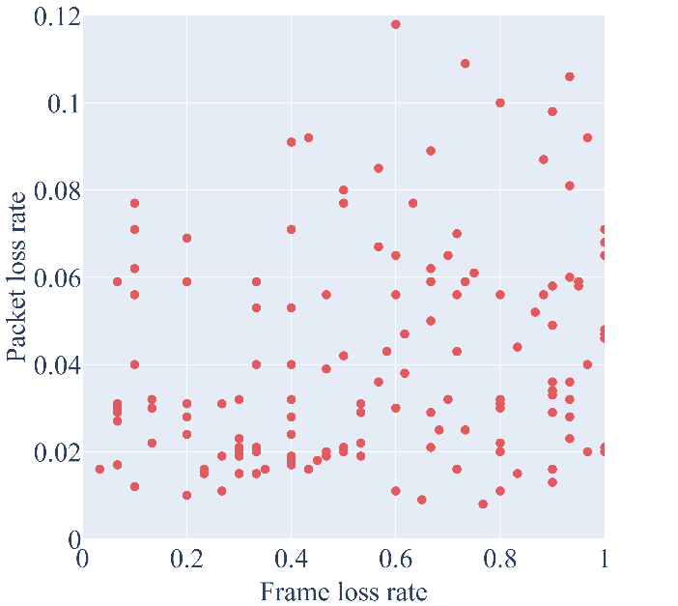  Figure 6: Packet loss rate and frame loss rate of IPP encoding PVSs

Table 13: PCC of all-intra encoding and IPP encoding
GOP structure | PCC
All-intra | 0.590
IPP | 0.226

Next, to determine the effect of the decrease in the correlation between packet loss and frame loss on estimation accuracy, the estimation accuracies in modes 2 and 3 with and without packet loss are checked. Table 14 shows the RMSE and PCC of modes 2 and 3 for videos with and without packet loss. Figure 7 shows scatter plots for the object-recognition ratios of modes 2 and 3 for videos with and without packet loss. From these table and figures, RMSEs without packet loss of modes 2 and 3 are the same. However, the RMSE with packet loss of mode 2 is larger than that of mode 3. In mode 3, since the frame loss rate is inputted and the effect of frame loss can be considered, the estimation accuracy of mode 3 is higher than that of mode 2 for PVSs with packet loss.

Table 14: RMSE and PCC for each with and without packet loss of the proposed model
 |  | The number of PVSs | Mode 2 | Mode 3
RMSE | Without packet loss | 148 | 0.183 | 0.183
RMSE | With packet loss | 148 | 0.379 | 0.289
PCC | Without packet loss | 148 | 0.851 | 0.851
PCC | With packet loss | 148 | 0.321 | 0.708

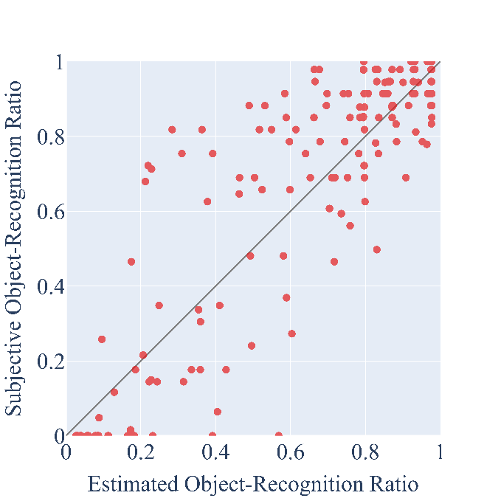  a) Mode 3 without packet loss | 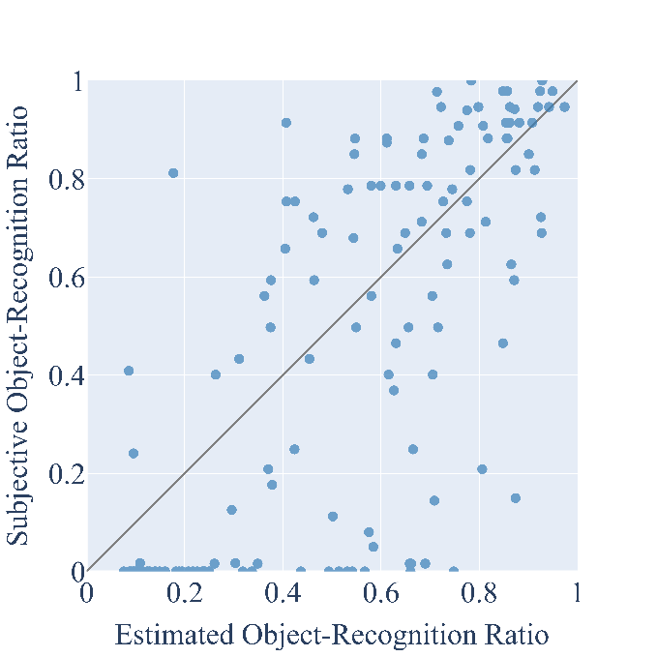  b) Mode 3 with packet loss
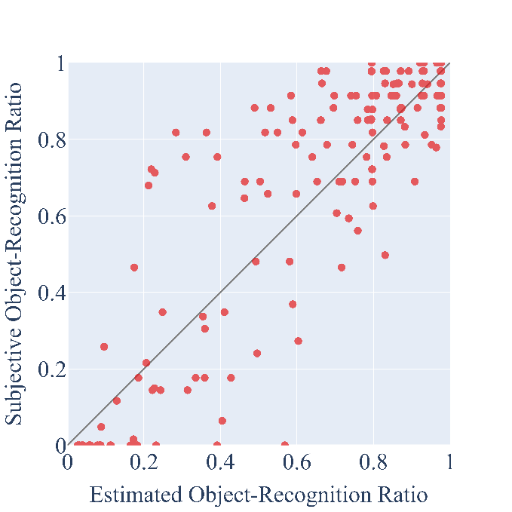  c) Mode 2 without packet loss | 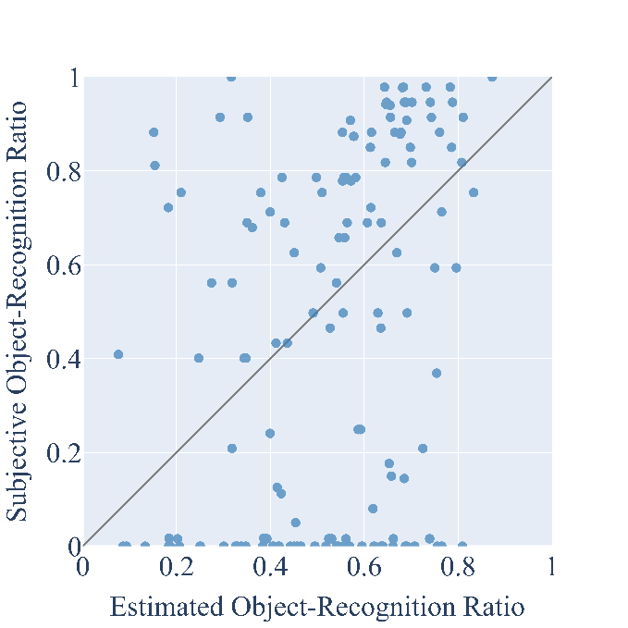  d) Mode 2 with packet loss
Figure 7: Performance of the model for each mode with and without packet loss

- Proposals
In this contribution, the estimation results of the validation experiment with IPP encoding videos are shown. The result shows that all modes have statistically significant differences between the baseline model. In addition, since there is a weak correlation between the packet loss rate and frame loss rate in IPP encoding, the results show statistically significant differences between modes 0 and 1, as well as modes 2 and 3. Depending on the encoding method, the modes that show significant differences vary. Therefore, recommendations need to be made for all modes in order to support various encoding methods.

- References
[1] ITU-T SG12 (Study Period 2022-2024) Contribution 203, Draft Terms of Reference (ToR) P.obj-recog
[2] ITU-T SG12 (Study Period 2022-2024) Contribution 204, Draft Test Plan of P.obj-recog
[3] ITU-T SG12 (Study Period 2025-2028) Contribution 7, Performance of proposed model for validation data
[4] ITU-T SG12, P.1401: Methods, metrics and procedures for statistical evaluation, qualification and comparison of objective quality prediction models, 2020

______________

Appendix I

P.obj-recog model Building Blocks
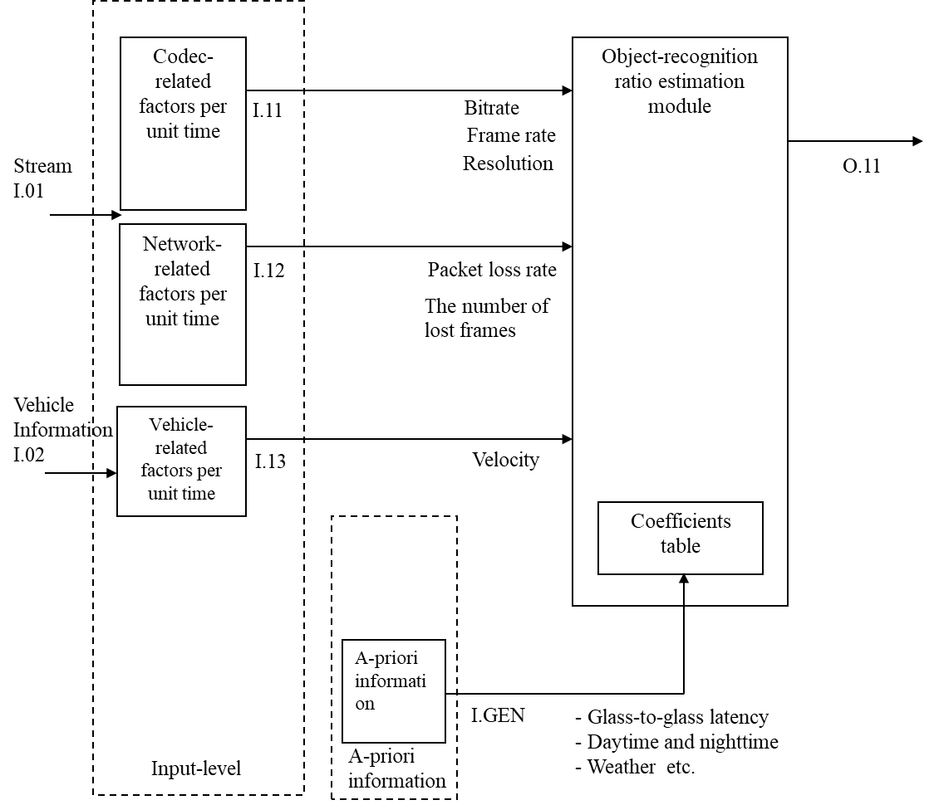
Figure 1 shows the building blocks of the P.obj-recog model, and Table 1 lists the operational modes. The model’s input parameters are shown in Figure 1.

Figure 8: Building blocks of the model

Table 15: P.obj-recog modes of operation
Mode | Input
0 | Meta-data and packet loss information
1 | Meta-data and frozen video frame information
2 | Meta-data, packet loss information and autonomous vehicle’s velocity
3 | Meta-data, frozen video frame information, and autonomous vehicle’s velocity

The details of input parameters and output are as follows:

I.11: Codec-related factors
Video resolution (pels); video bitrate (kbps); video frame rate (fps) per unit time for all modes.

I.12: Network-related factors
- Video packet loss rate (%) per unit time for modes 0 and 2.
- The number of lost video frames (frames) per unit time for modes 1 and 3. Since the video frame loss pattern (e.g., random, burst) is not considered, the value of this factor becomes the same when the number of lost frames in one unit of time is the same, even if the frame loss patterns are different, as shown in Figure 2.
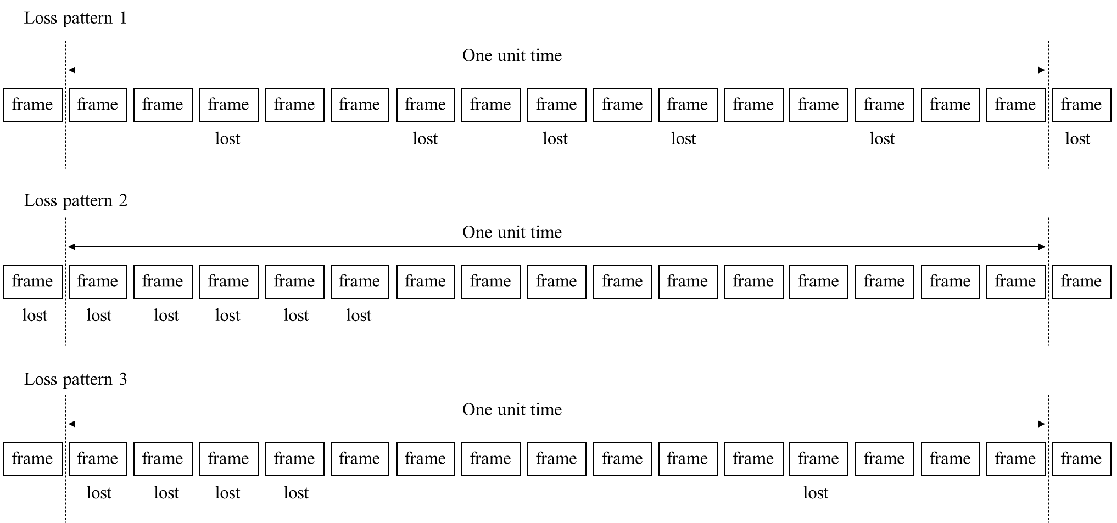
Figure 9: Example loss pattern where the number of lost video frames per unit time is 5

I.13: Vehicle-related factors
Autonomous vehicle’s velocity (km/h) per unit time. Note that this factor is used for modes 2 and 3.

I.GEN: A priori information for estimation module
A priori information for the estimation module includes the following:
- Packet-loss error concealment
  - Freezing with skipping
  - Block noise
- Codec
  - Codec
  - Profile
  - GOP
- Source-related factors
  - Object color
  - Object pixel size on screen at a specific distance
  - Object background
  - Weather
  - Daytime and nighttime
- Network latency factors
  - Glass-to-glass latency
  - Control latency
- Camera-related factors
  - Camera mode
  - Focal length
  - Field of view
  - Image stabilization
  - Auto white balance delay
  - Lens flare
- Reaction time factors
  - Required reaction time
- Road-related factors
  - Road surface coefficient of friction (This is determined on the basis of weather)

O.11: Output object-recognition ratio
This model outputs the object-recognition ratio. The object-recognition ratio is defined as the percentage of observers who can recognize objects within the time it is possible to prevent the vehicle from colliding with objects when these objects appear a target distance away from the autonomous vehicle.

Appendix II

Calculation of target distance
In estimating the object recognition ratio, several delays need to be considered. Figure 10 shows the workflow of events from the observer at the monitoring center recognizing objects in a surveillance video to the stopping of an autonomous car.
The surveillance video is encoded and sent to the monitoring center via a radio access network. Therefore, there are delays associated with encoding and network latency. In addition, there is a decoding and display latency until the video is displayed on the display. The sum of these delays is called glass-to-glass latency ($L_{G2G}$), which is defined in a-priori information.
Required reaction time ($L_{reaction}$) is the time between an observer recognizing an object and sending a brake command to an autonomous car, which is defined in a-priori information. This time relates to the observer’s ability, such as viewing angle or contrast sensitivity. $L_{reaction}$ depends on how much time the designer of the autonomous driving system gives the observer to recognize the object. In general, an observer takes at least 0.5 seconds to react to an object, so this required reaction time must be considered at this point.
Control latency ($L_{control}$) is the time between an observer sending a brake command and the autonomous car really starting to stop, which is defined in a-priori information. The sum of glass-to-glass latency, required reaction time and control latency is defined as total latency ($L_{total}$) in seconds, and this is given in the following equation.

$$L_{total}=L_{G2G}+L_{reaction}+L_{control}$$

The brake distance ($D_{break}$) in meters is given in the following equation using the autonomous car’s velocity $V$ km/h and coefficient of friction $μ$ ($μ$ is the parameter depending on weather). In modes 0 and 2 where the autonomous car’s velocity cannot be used, V is set to 40 (Max value in Table 1) considering the safety side.
$$D_{break}= \frac{V^{2}}{254μ}$$

Therefore, the target distance X in meters is given in the following equation.

$$X=\frac{VL_{total}}{3.6}+D_{break}$$
The recognition ratio is the percentage of observers who can recognize objects and send brake commands within the time it is possible to properly avoid a collision after the objects appear in the surveillance video at the target distance from the autonomous car.
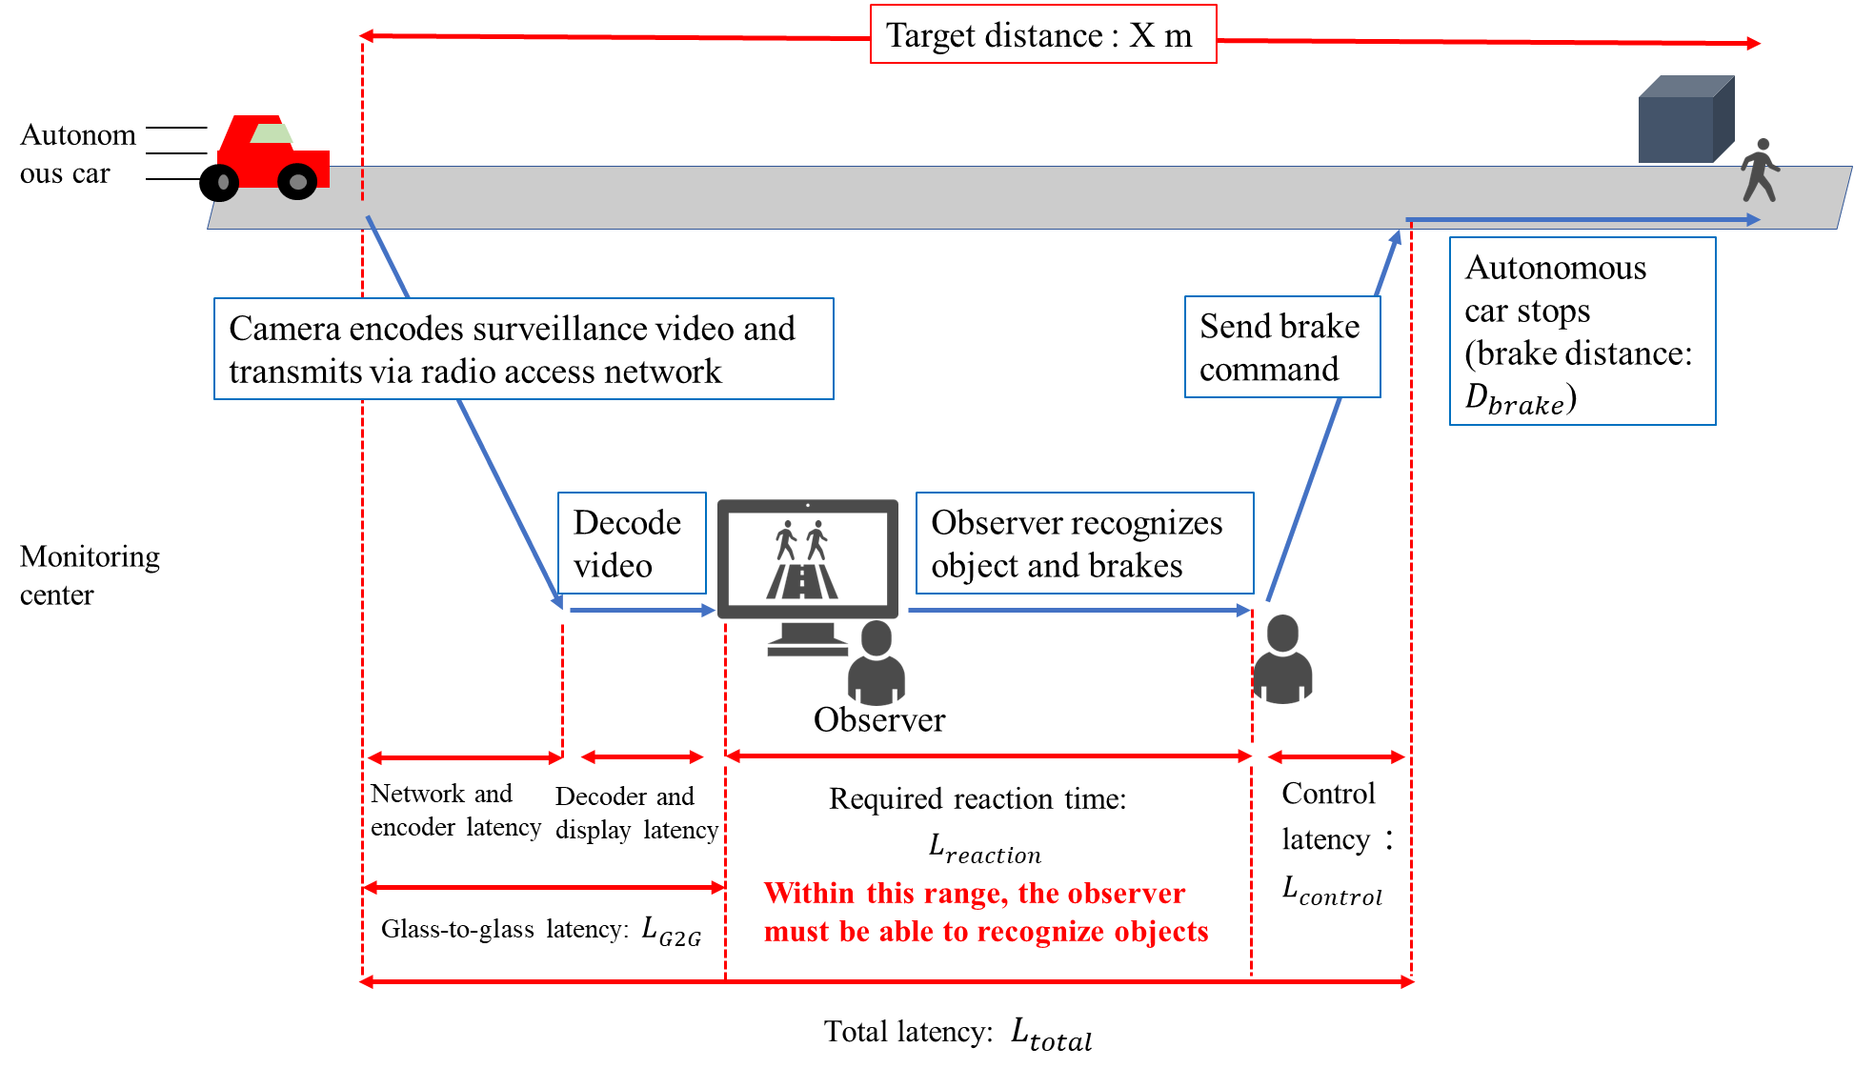
Figure 10 The workflow of events from the observer at the monitoring center recognizing objects in a surveillance video to the stopping of an autonomous car

Appendix III

Investigation into PVSs with low estimation accuracy
From the result, it was shown that the estimation accuracy of mode 3 is higher than that of mode 2. However, some PVSs with packet loss are not estimated well in mode 3. The main cause of this estimated error is the timing of packet loss in the appearance of the object.
In this model, the packet loss ratio is calculated as the packet loss percentage in one second from when a person appears in PVS. Since the location of packet loss in this one second is not considered, the subjective object-recognition ratio differs depending on the location of packet loss in the one second. Figures 11 and 12 show an example of a PVS thumbnail with this pattern of packet loss. In the IPP encoding, since the I frame interval is one second, an I frame occurs somewhere within the one second after a person appears, but the timing of the I-frame occurrence is random. Figure 11 shows a situation where the I-frame occurs halfway through the one-second interval, and frame loss occurs in the first half. In this situation, the person cannot be recognized in the first half of the second. In the second half of the second, the person can be recognized. However, participants must recognize the remaining short time (within 0.5 seconds), and the object-recognition ratio will decrease. Figure 12 shows a situation where a large packet loss occurs in the first half of the second in which the person appears. In this situation, the person can be recognized in the first half of the one second, therefore the subjective object-recognition ratio is high.
These two results show that even with the same frame loss rate, the estimation results differ in these situations. In IPP encoding, frame loss occurs continuously compared to all-intra encoding. Therefore, the timing of packet loss has a significant impact, leading to a decrease in estimation accuracy.

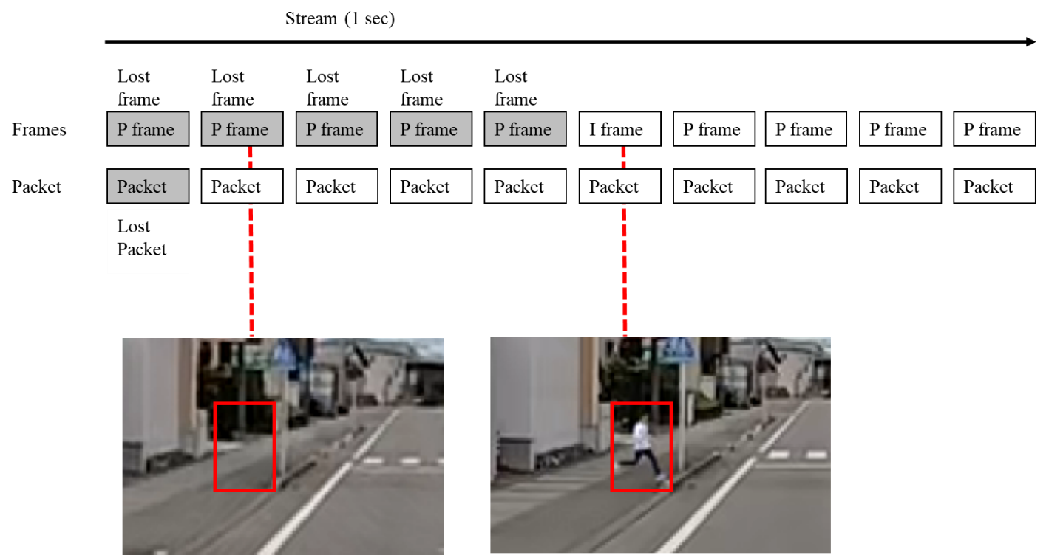
Figure 11: Example of concentrated packet loss in the second half of the second in which the person appears

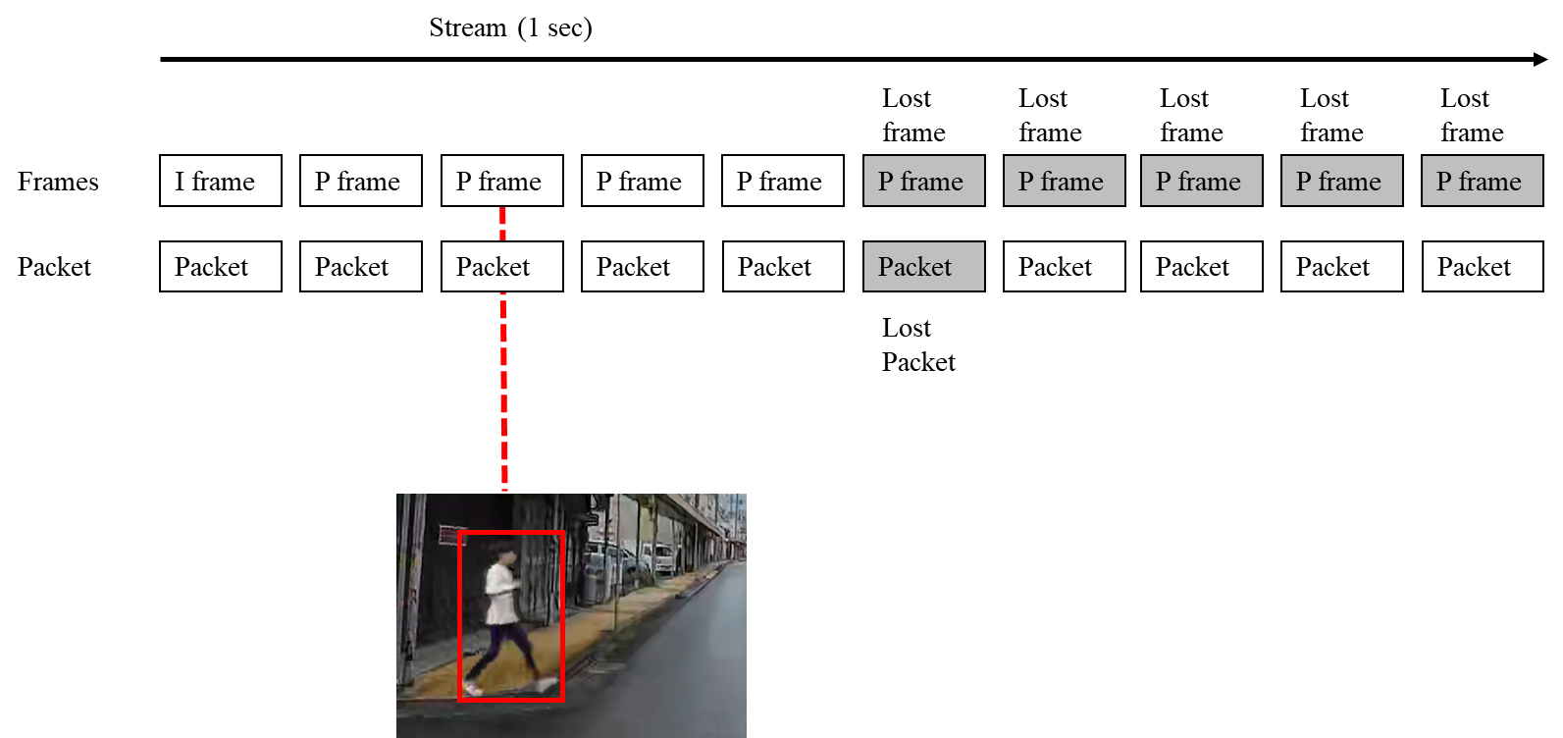
Figure 12: Example of concentrated packet loss in the first half of the second in which the person appears

