 | INTERNATIONAL TELECOMMUNICATION UNION  TELECOMMUNICATION  STANDARDIZATION SECTOR  STUDY PERIOD 2025-2028 |  |  |  | SG12–C0001
 |  |  |  |  | STUDY GROUP 12
 |  |  |  |  | Original: English
Question(s): |  |  | 19/12 |  | Menlo Park, California, 7-8 May 2025​​
CONTRIBUTION
Source: |  |  | NTT
Title: |  |  | Draft Recommendation P.obj-recog
Contact: |  | Masanori Koike  Japan  NTT |  | Tel: +81-422-59-4453  E-mail: masanori.koike@ntt.com
Contact: |  | Kazuhisa Yamagishi  Japan  NTT |  | Tel: +81-422-59-4397  E-mail: kazuhisa.yamagishi@ntt.com
Contact: |  | Noritsugu Egi  Japan  NTT |  | Tel: +81-422-59-4008  E-mail: noritsugu.egi@ntt.com
Contact: |  | Yoichi Matsuo  Japan  NTT |  | Tel: +81-422-59-4519  E-mail: yoichi.matsuo@ntt.com
Contact: |  | Masahiro Yokota  Japan  NTT |  | Tel: +81-422-59-2444  E-mail: masahiro.yokota@ntt.com

Abstract: | This document is Draft Recommendation P.obj-recog.

Recommendation ITU-T <No.>
<Parametric object-recognition-ratio-estimation model for remote monitoring of surveillance video delivered from autonomous vehicle>
Summary
This Recommendation provides a parametric object-recognition-ratio-estimation model to check whether an observer in a monitoring center can recognize an object (e.g., a person who jumps out onto the road or debris on the road) while viewing the video taken by an autonomous vehicle’s surveillance camera and delivered to the monitoring center. This object-recognition ratio can be used as an indicator to check whether the surveillance video delivered to the remote monitoring center is of sufficient quality for remote monitoring around the autonomous vehicle.
The input used by the model consists of information obtained from video streams and vehicle information. Four different modes, which are called “modes of operation”, can be used for estimating the object-recognition ratio in this Recommendation:
- Mode 0: Information obtained from the video stream, such as the video resolution, video bitrate, and video frame rate, in addition to packet loss information.
- Mode 1: Information obtained from the video stream and frozen video frame information based on frame inspection.
- Mode 2: The same information as mode 0, in addition to vehicle velocity.
- Mode 3: The same information as mode 1, in addition to vehicle velocity.

Keywords
Autonomous Driving, Object Recognition, Surveillance Video, Subjective Experiment

1 Scope
This Recommendation provides a parametric object-recognition-ratio-estimation model to check whether an observer in a monitoring center can recognize an object (e.g., a person who jumps out onto the road or debris on the road) when viewing the video taken by an autonomous vehicle’s surveillance camera and delivered encoded video to a monitoring center (hereafter, the video viewed at this monitoring center is referred to as surveillance video).
No driver is needed in fully autonomous driving, and the autonomous vehicle operates autonomously in any location, road, and weather. For safe driving, objects that interfere with driving need to be automatically detected, for example, to brake and decelerate the vehicle. Therefore, an autonomous vehicle is equipped with object-detection technology [b-detection] to detect objects around the autonomous vehicle by analyzing videos captured by the automotive cameras and LiDAR data. Under certain conditions, such as on a highway, object-detection technology in autonomous driving works well. On the other hand, current object-detection technology is challenging to use on local streets because various objects appear, such as traffic signs or pedestrians.
In several countries, remote monitoring is legally required for autonomous driving to ensure safety. In Germany, legislation on autonomous driving has been passed that states that remote monitoring is necessary [b-Germany]. Also, under the revised Road Traffic Act in Japan, remote monitoring is needed when operating unattended autonomous vehicles in specific areas [b-Japan]. In France, the revised transport law requires that the safety of autonomous driving is ensured through remote monitoring [b-France]. On the basis of the above, to check whether remote monitoring is being carried out properly, it is important to check whether an observer at the monitoring center can recognize an object using the surveillance video.
However, since the surveillance video is encoded and delivered through a network, video quality may degrade as the bandwidth of the wireless network decreases, making it difficult for observers to recognize objects in the video. It is a meticulous and difficult task for the observer to continuously judge whether the object can be recognized from surveillance video in real time. Furthermore, in such a case, the observer needs to react and brake the autonomous vehicle immediately when an object appears, so what is necessary is to confirm that an object appears in the surveillance video rather than to identify the object type. Therefore, to check whether remote monitoring is being carried out properly, a parametric object-recognition-ratio estimation model needs to be developed to estimate the object-recognition ratio, which is the percentage of observers who can recognize objects within the time it is possible to prevent the vehicle from colliding with them when these objects appear a target distance away from the autonomous vehicle.
There is a wide range of cases where object recognition is required for remote monitoring in autonomous driving, e.g., there may be objects on the road or pedestrians jumping out onto the road. Since a model corresponding to all these situations is difficult to construct, a model needs to be built that considers the riskiest situations for autonomous driving. From the viewpoint of the risk of a serious accident and the difficulty in recognition (i.e., the need for instantaneous judgment by an observer), the case in which an object appears in front of the vehicle is covered in this Recommendation.
The object-recognition ratio is affected by various factors. The video degraded due to the video bitrate reduction, which makes object recognition difficult and, therefore, depends on the parameters of the codec. Since video degradation by packet loss makes object recognition difficult, it also depends on packet loss. The network latency affects the object-recognition ratio because if the network latency is long, the observer must recognize objects earlier to react. The camera specifications (e.g., focal length and field of view) and problems (e.g., dirt on the lens) also affect the object-recognition ratio. A parametric object-recognition-ratio estimation model is developed because a model that covers all patterns of these factors is difficult to develop. Specifically, the model takes the encoding, packet loss, and velocity information as input and uses a coefficient set determined by other factors (e.g., object, camera, and weather) on the basis of a-priori information. Also, depending on the configuration of the remote monitoring system, the velocity of the autonomous vehicle and the effect of packet loss on the video (i.e., video-frame-loss information) may not be possible to obtain. Therefore, the model has four modes depending on the available input information.

2 References
The following ITU-T Recommendations and other references contain provisions which, through reference in this text, constitute provisions of this Recommendation. At the time of publication, the editions indicated were valid. All Recommendations and other references are subject to revision; users of this Recommendation are therefore encouraged to investigate the possibility of applying the most recent edition of the Recommendations and other references listed below. A list of the currently valid ITU-T Recommendations is regularly published. The reference to a document within this Recommendation does not give it, as a stand-alone document, the status of a Recommendation.
[ITU-T P.912] Recommendation ITU-T P.912 (2016), Subjective video quality assessment methods for recognition tasks.

3 Definitions

3.1 Terms defined elsewhere
This Recommendation uses the following terms defined elsewhere:
3.1.1 Timed task method [ITU-T P.912]: A viewer is asked to watch for a particular action or object to be recognized in the video clip.

3.2 Terms defined in this Recommendation
This Recommendation defines the following terms:
3.2.1 Object-recognition ratio: The percentage of observers who can recognize objects within the time it is possible to prevent the vehicle from colliding with them when these objects appear a target distance away from the autonomous vehicle.
3.2.2 Target distance: The distance from the surveillance camera that captures the surveillance video to the objects when they appear, which is derived by taking into account required reaction time, glass-to-glass latency, control latency, and break distance, which is calculated by the vehicle’s velocity or coefficient of friction.
3.2.3 Required reaction time: The time in which an observer must recognize the object and react after the object appears.
3.2.4 Glass-to-glass latency: The sum of delays associated with network, encoding, decoding and display latency.
3.2.5 Control latency: The time between an observer sending a brake command and the autonomous vehicle really starting to stop.

4 Abbreviations and acronyms
This Recommendation uses the following abbreviations and acronyms:
GOP Group of Pictures
HEVC High-Efficiency Video Coding
PCC Pearson Correlation Coefficient
PVS Processed Video Sequences
RMSE Root Mean Square Error
RTP Real-time Transport Protocol
UDP User Datagram Protocol
IP Internet Protocol

5 Conventions
None

6 Areas of application

6.1 Applications for which the model is intended
The application area for this Recommendation is a remote monitoring system to which surveillance video encoded in an autonomous vehicle is delivered to the monitoring center. A remote monitoring system is based on the RTP/UDP/IP and UDP/IP protocols because low latency is needed for surveillance video, and UDP-based streaming is widely used for real-time streaming.

6.2 General application range to which the model is applicable
The application range for which the model has been validated is detailed in Table 1.

Table 1: Application range for which the model has been validated
Display resolution | 1920 × 1080 pels
Unit time for video and network information acquisition | 1 second
Required reaction time | 1 second
Glass-to-glass latency and control latency | Total 1.5 seconds
Timeframe | Daytime | Nighttime
Weather | Sunny
Road surface coefficient of friction | 0.7 (Note 1)
Object color and size | Children (about 120 cm) wearing white clothes
Autonomous vehicle’s velocity | 10 - 40 km/h
Packet loss error concealment | Freezing with skipping
Packet loss rate | 0 - 10 %
Frame loss rate | 0 - 95 %
Video codec | H.265/HEVC
Profile | Main
Group of pictures (GOP) | All-intra
Video resolution | 640×360 (230,400) – 1920×1080 (2,073,600) pels (Note 2)
Video bitrate | 200 – 5,000 kbps
Video frame rate | 10 - 60 fps

Note 1 - This parameter depends on the road surface and weather, i.e., the coefficient of friction is smaller in the case of rain.
Note 2 – Video resolution is defined as the number of pels (width × height)

6.3 Modes of operation
The model consists of four modes of operation, which are defined in Table 2. It is recommended to use mode 3 if possible. However, if velocity or video-frame-loss information is not available, modes 0 to 2 will be used. Detailed input information of each mode is provided in Section 7.1.

Table 2: The model modes of operation
Mode | Input
0 | Meta-data and packet loss information
1 | Meta-data and frozen video frame information
2 | Meta-data, packet loss information and autonomous vehicle’s velocity
3 | Meta-data, frozen video frame information, and autonomous vehicle’s velocity

7 Building blocks
The building blocks of the model are depicted in Figure 2 below. This Recommendation uses codec-related factors such as video bitrate, network-related factors such as packet loss rate, and vehicle-related factors such as the vehicle’s velocity as input. In addition, the coefficient is determined by utilizing a-priori-information such as glass-to-glass latency, weather, and timeframe (i.e., daytime or nighttime). The details of this input are shown in Section 7.1.
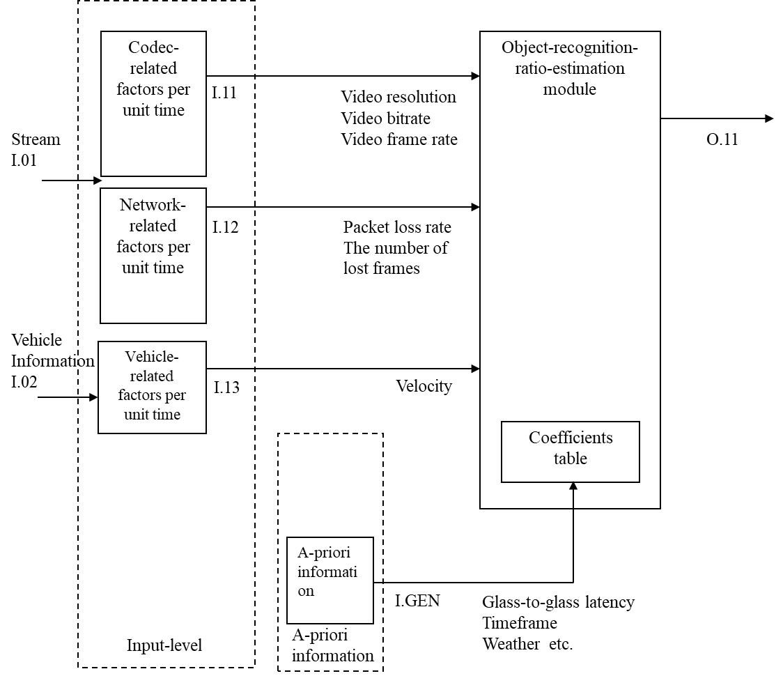
Figure 2: Building blocks of the model

7.1 Model inputs
The model receives the following input signal:

I.11: Codec-related factors
Video resolution (pels); video bitrate (kbps); video frame rate (fps) per unit time for all modes.

I.12: Network-related factors
- Video packet loss rate (%) per unit time for modes 0 and 2.
- The number of lost video frames (frames) per unit time for modes 1 and 3. Since the video-frame-loss pattern (e.g., random, burst) is not considered, the value of this factor becomes the same when the number of lost frames in one unit of time is the same, even if the frame loss patterns are different, as shown in Figure 3.
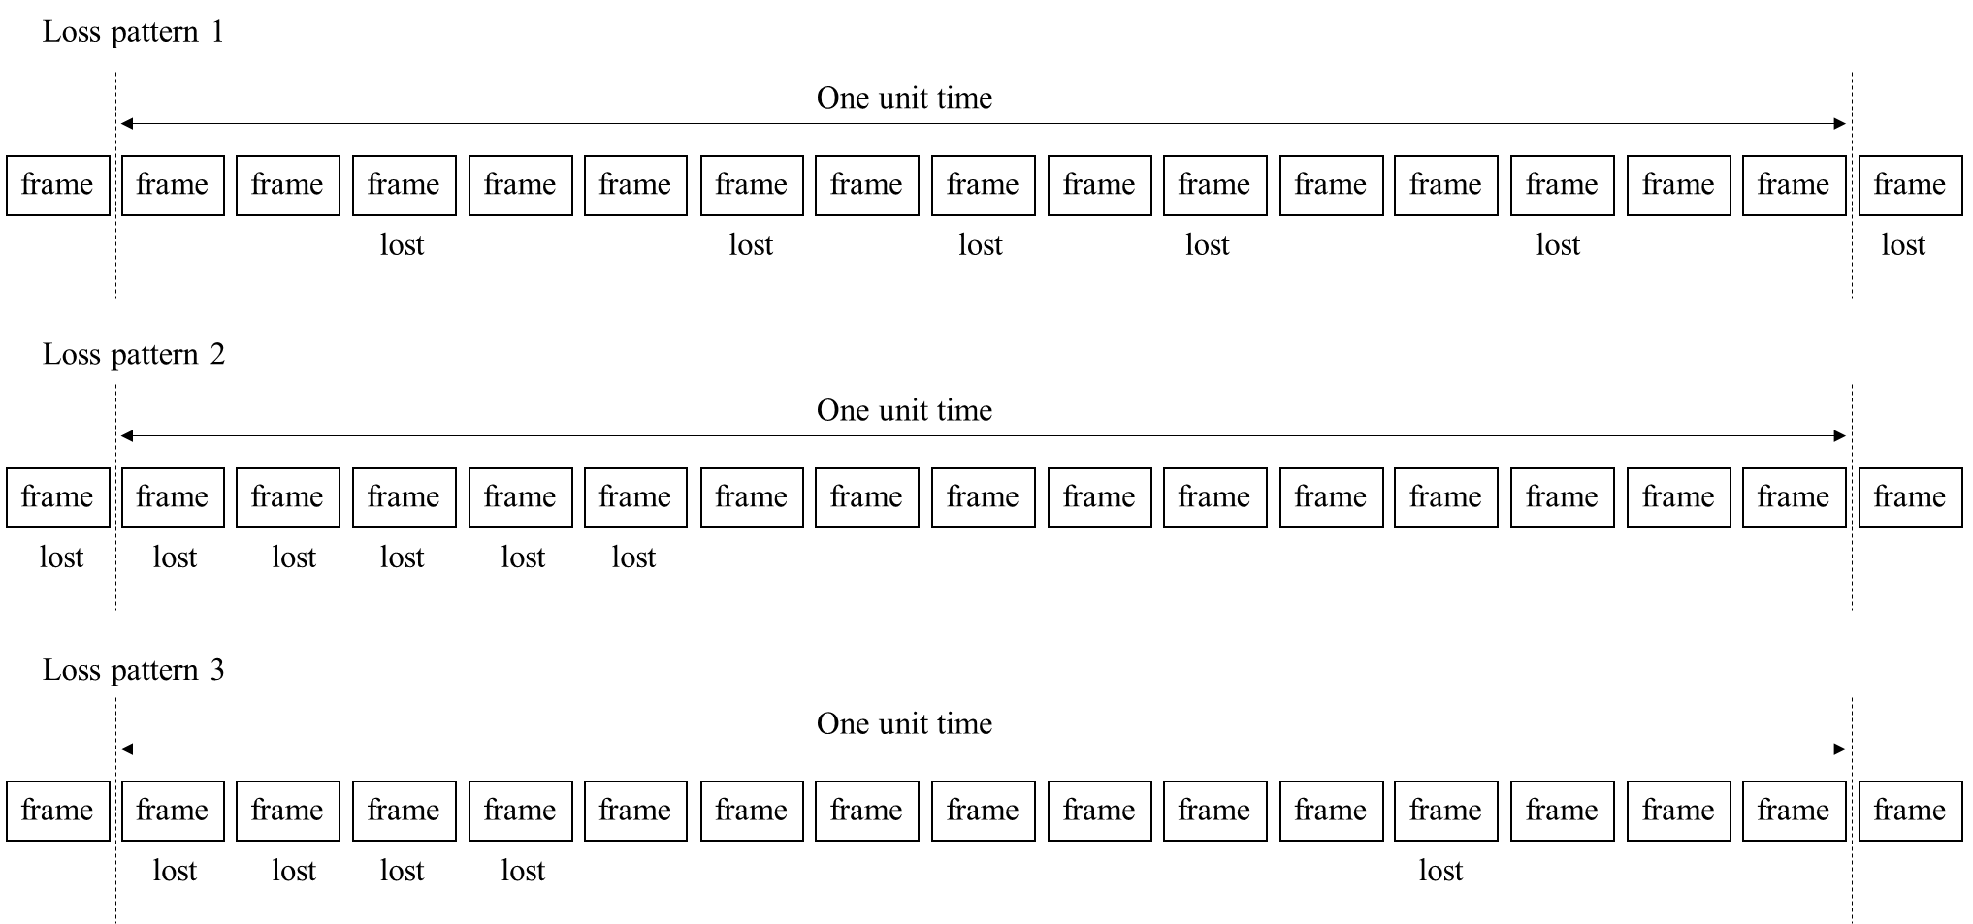
Figure 3: Example loss pattern where the number of lost video frames per unit time is 5

I.13: Vehicle-related factors
Autonomous vehicle’s velocity (km/h) per unit time. Note that this factor is used for modes 2 and 3.

I.GEN: A-priori information for estimation module
A-priori information for the estimation module includes the following:
- Display resolution
- Packet loss error concealment
- Codec
  - Codec
  - Profile
  - GOP
- Source-related factors
  - Object color
  - Object size
  - Weather
  - Timeframe
- Network latency factors
  - Glass-to-glass latency
  - Control latency
- Reaction time factors
  - Required reaction time
- Camera-related factors
  - Camera mode
  - Focal length
  - Field of view
  - Image stabilization
  - Auto white balance delay
  - Lens flare
- Road-related factors
  - Road surface coefficient of friction (This is determined on the basis of weather)

7.2 Model outputs

O.11: Output object-recognition ratio
This model outputs the object-recognition ratio from 0 to 1. As described in Section 1, the object-recognition ratio is defined as the percentage of observers who can recognize objects within the time it is possible to prevent the vehicle from colliding with them when these objects appear a target distance away from the autonomous vehicle.

8 The model algorithm
The model in this Recommendation provides O.11 (object-recognition ratio) from 0 to 1. The model consists of four different modes, and the inputs differ between each mode. The following parameters are used in the description of the model:
- $t$: the unit time for video and network information acquisition
- $b$: the video bitrate per unit time.
- $f$: the video frame rate per unit time.
- $r$: the video resolution (the number of pels $(height·width)$ ) per unit time.
- $v$: the vehicle’s velocity per unit time.
- $l$: the number of lost frames. It is directly measured in modes 1 and 3. By definition, since the number of lost frames is not measured in modes 0 and 2, $l$ is estimated by packet loss rate.
- $p$: packet loss rate per unit time.
- $X$: object-recognition ratio if no packet loss or frame loss occurred.

The object-recognition ratio $O.11$ is calculated as follows:

$$O.11=\frac{X}{1+{\left(-\frac{c_{1}}{f^{c_{2}}}\log\left(\frac{f·t-l}{f·t} \right)\right)}^{c_{3}}},$$ | (1)

$$X=A_{1}-\frac{A_{1}}{1+{\left(\frac{b}{A_{2}}\right)}^{A_{3}}}.$$ | (2)
In modes 0 and 2, $l$ is not directly obtained, so it is calculated as follows:
$$l=\left(1-{\left(1-p\right)}^{\frac{c_{11}+b}{f^{c_{12}}}+c_{13}}\right)f·t,$$ | (3)
where $c_{1}$ – $c_{3}$ and $c_{11}$ – $c_{13}$ are the coefficients used in the model.
Eq. (2) is common to all four modes. However, the definitions of $A_{1}-A_{3}$ differ depending on the modes. In modes 0 and 1, the vehicle’s velocity cannot be used and $A_{1}-A_{3}$ are calculated without velocity. In modes 2 and 3, velocity can be used, and $A_{1}-A_{3}$ are calculated with velocity.
In modes 0 and 1, $A_{1}-A_{3}$ are calculated as follows:
 | $$A_{1}=c_{4}-\frac{c_{5}}{r},$$ | (4)
 | $$A_{2}=c_{6}·f^{c_{7}},$$ | (5)
 | $$A_{3}=c_{8}.$$ | (6)
In modes 2 and 3, $A_{1}-A_{3}$ are calculated as follows:
 | $$A_{1}=1-c_{4}·v^{c_{5}}-\frac{c_{6}}{r},$$ | (7)
 | $$A_{2}=\left(c_{7}+c_{8}·v\right)·f^{c_{9}},$$ | (8)
 | $$A_{3}=c_{10},$$ | (9)
where $c_{4}$ – $c_{10}$ are the coefficients used in the model.
Equations used per mode are listed in Table 3.
Table 3 Equations per mode
Mode | 0 | 1 | 2 | 3
Equation | - – (6) | (1), (2), and (4) – (6) | (1) – (3) and (7) – (9) | (1), (2), and (7) – (9)

The sets of a-priori information and coefficients are listed in Tables 4-0 to 4-3 for each mode.

Table 4-0 A-priori information and coefficients sets of mode 0
A-priori information | Timeframe | Daytime | Nighttime
A-priori information | Codec | H.265/HEVC
A-priori information | GOP structure | All-intra
Coefficients | $$c_{1}$$ | 10.16 | 14.56
Coefficients | $$c_{2}$$ | 0.8337 | 1.021
Coefficients | $$c_{3}$$ | 2.198 | 4.060
Coefficients | $$c_{4}$$ | 0.9576 | 0.8514
Coefficients | $$c_{5}$$ | 25.03 | 25.00
Coefficients | $$c_{6}$$ | 43.25 | 44.18
Coefficients | $$c_{7}$$ | 0.7807 | 0.8791
Coefficients | $$c_{8}$$ | 1.293 | 8.837
Coefficients | $$c_{9}$$ | - | -
Coefficients | $$c_{10}$$ | - | -
Coefficients | $$c_{11}$$ | 0.03263 | 0.05923
Coefficients | $$c_{12}$$ | 0.8199 | 1.004
Coefficients | $$c_{13}$$ | 3.340 | 3.773

Table 4-1 A-priori information and coefficients sets of mode 1
A-priori information | Timeframe | Daytime | Nighttime
A-priori information | Codec | H.265/HEVC
A-priori information | GOP structure | All-intra
Coefficients | $$c_{1}$$ | 9.694 | 12.76
Coefficients | $$c_{2}$$ | 0.9096 | 1.045
Coefficients | $$c_{3}$$ | 2.151 | 2.682
Coefficients | $$c_{4}$$ | 0.9182 | 0.8658
Coefficients | $$c_{5}$$ | 25.13 | 25.00
Coefficients | $$c_{6}$$ | 48.15 | 44.36
Coefficients | $$c_{7}$$ | 0.7750 | 0.8795
Coefficients | $$c_{8}$$ | 1.749 | 8.335

Table 4-2 A-priori information and coefficients sets of mode 2
A-priori information | Timeframe | Daytime | Nighttime
A-priori information | Codec | H.265/HEVC
A-priori information | GOP structure | All-intra
Coefficients | $$c_{1}$$ | 8.581 | 12.67
Coefficients | $$c_{2}$$ | 0.6270 | 0.9969
Coefficients | $$c_{3}$$ | 2.567 | 3.292
Coefficients | $$c_{4}$$ | 0.00001010 | 0.0004655
Coefficients | $$c_{5}$$ | 2.735 | 1.680
Coefficients | $$c_{6}$$ | 7049 | 25.00
Coefficients | $$c_{7}$$ | 23.12 | 37.34
Coefficients | $$c_{8}$$ | 1.637 | 0.3471
Coefficients | $$c_{9}$$ | 0.7658 | 0.8736
Coefficients | $$c_{10}$$ | 3.291 | 9.254
Coefficients | $$c_{11}$$ | 0.01239 | 0.06560
Coefficients | $$c_{12}$$ | 0.6402 | 0.9800
Coefficients | $$c_{13}$$ | 2.670 | 3.641

Table 4-3 A-priori information and coefficients sets of mode 3
A-priori information | Timeframe | Daytime | Nighttime
A-priori information | Codec | H.265/HEVC
A-priori information | GOP structure | All-intra
Coefficients | $$c_{1}$$ | 6.272 | 14.36
Coefficients | $$c_{2}$$ | 0.7521 | 1.081
Coefficients | $$c_{3}$$ | 2.119 | 2.428
Coefficients | $$c_{4}$$ | 0.00001710 | 0.0001527
Coefficients | $$c_{5}$$ | 2.543 | 1.969
Coefficients | $$c_{6}$$ | 1009 | 25.00
Coefficients | $$c_{7}$$ | 12.60 | 36.45
Coefficients | $$c_{8}$$ | 1.960 | 0.3680
Coefficients | $$c_{9}$$ | 0.7732 | 0.8776
Coefficients | $$c_{10}$$ | 3.062 | 8.797

Annex A
Calculation of target distance

In estimating the object-recognition ratio, several delays need to be considered. Figure A-1 shows the workflow of events from the observer at the monitoring center recognizing objects in a surveillance video to the stopping of an autonomous vehicle.
The surveillance video is encoded and sent to the monitoring center via a radio access network. Therefore, there are delays associated with encoding and network latency. In addition, there is a decoding and display latency until the video is displayed on the display. The sum of these delays is called glass-to-glass latency ($L_{G2G}$), which is defined in a-priori information.
Required reaction time ($L_{reaction}$) is the time between an observer recognizing an object and sending a brake command to an autonomous vehicle, which is defined in a-priori information. This time relates to the observer’s ability, such as viewing angle or contrast sensitivity. $L_{reaction}$ depends on how much time the designer of the autonomous driving system gives the observer to recognize the object. In general, an observer takes at least 0.5 seconds to react to an object, so this required reaction time must be considered at this point.
Control latency ($L_{control}$) is the time between an observer sending a brake command and the autonomous vehicle really starting to stop, which is defined in a-priori information. The sum of glass-to-glass latency required reaction time and control latency is defined as total latency ($L_{total}$) in seconds, and this is given in the following equation.

$$L_{total}=L_{G2G}+L_{reaction}+L_{control}$$

The brake distance ($D_{break}$) in meters is given in the following equation using the autonomous vehicle’s velocity $V$ km/h and coefficient of friction $μ$ ($μ$ is the parameter depending on the weather).
$$D_{break}= \frac{V^{2}}{254μ}$$

Therefore, the target distance X in meters is given in the following equation.

$$X=\frac{V·L_{total}}{3.6}+D_{break}$$
The object-recognition ratio is the percentage of observers who can recognize objects within the time it is possible to prevent the vehicle from colliding with them when these objects appear a target distance away from the autonomous vehicle.

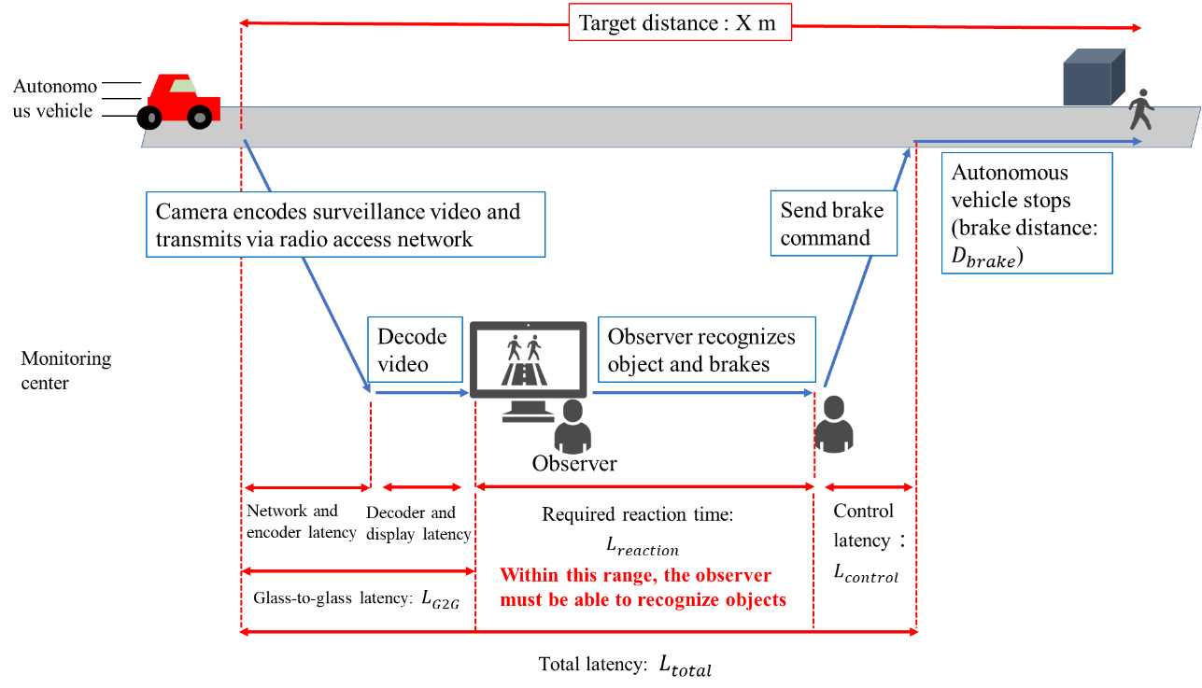
Figure A-1: The workflow of events from the observer at the monitoring center recognizing objects in a surveillance video to the stopping of an autonomous vehicle

Appendix I
Performance figures
In this appendix, the root mean squared error (RMSE) and Pearson correlation coefficient (PCC) are reported in Tables I.0 - I.3. The parametric object-recognition-estimation model per mode was validated on 296 daytime PVSs and 296 nighttime PVSs.
The dataset of the object-recognition ratio is obtained by the subjective assessment test for the recognition task. In the subjective assessment, the participants watch surveillance videos in which objects appear at the target distance, and whether the participants can recognize objects within the required reaction time is recorded. The object-recognition ratio of the dataset is the percentage of participants who can recognize objects within the time. The subjective assessment methods described in [ITU-T P.912] can be applied to the timed task method.

Table I.0 RMSE and PCC of the model of mode 0
A-priori information | Timeframe | Daytime | Nighttime
A-priori information | Codec | H.265/HEVC
A-priori information | GOP structure | All-intra
Score | RMSE | 0.254 | 0.216
Score | PCC | 0.547 | 0.687

Table I.1 RMSE and PCC of the model of mode 1
A-priori information | Timeframe | Daytime | Nighttime
A-priori information | Codec | H.265/HEVC
A-priori information | GOP structure | All-intra
Score | RMSE | 0.247 | 0.202
Score | PCC | 0.583 | 0.741

Table I.2 RMSE and PCC of the model of mode 2
A-priori information | Timeframe | Daytime | Nighttime
A-priori information | Codec | H.265/HEVC
A-priori information | GOP structure | All-intra
Score | RMSE | 0.212 | 0.176
Score | PCC | 0.715 | 0.819

Table I.3 RMSE and PCC of the model of mode 3
A-priori information | Timeframe | Daytime | Nighttime
A-priori information | Codec | H.265/HEVC
A-priori information | GOP structure | All-intra
Score | RMSE | 0.204 | 0.164
Score | PCC | 0.743 | 0.861

Appendix II
Camera-related factors

This appendix presents the camera-related factors of the model used in the validation experiment. These values of camera-related factors of each daytime and nighttime PVSs in the validation experiment are shown in Table II.1. In the validation experiment, these values are used as representative values of taking surveillance videos for autonomous driving so that objects can be recognized in the surveillance videos with an appropriate size and appearance.

Table II.1 Parameters of camera-related factors of each daytime and nighttime PVSs
Timeframe | Daytime | nighttime
Camera mode | Fisheye disable mode
Camera focal length | 24 mm | 14mm
Camera field of view (Diagonal) | 95.5° | 114°
Camera image stabilization | Yes
Camera auto white balance delay | No
Lens flare | No

Bibliography
[b-German] Entwurf eines Gesetzes zur Änderung des Straßenverkehrsgesetzes und des Pflichtversicherungsgesetzes – Gesetz zum autonomen Fahren, 2021
[b-Japan] Initiatives for Realization of Automated Driving by Japan Police, ITS World Congress, 2022
[b-France] The French strategy for the development of automated road mobility 2020-2022, 9th GRVA, 2021
[b-detection] Y. Cai et al., “YOLOv4-5D: An Effective and Efficient Object Detector for Autonomous Driving,” IEEE Transactions on Instrumentation and Measurement, vol. 70, pp. 1-13, 2021
____________________

