INTERNATIONAL TELECOMMUNICATION UNION |  | Review Committee
TELECOMMUNICATION  STANDARDIZATION SECTOR  STUDY PERIOD 2013-2016 |  | TD 54 R1/RevCom
English only
Original: English
Question(s): | N/A | Geneva, 16 -17 January 2014
TD
Source: | Chairman, ITU-T RevCom
Title: | Statistics of SG activity analysis

Abstract
This TD provides the discussion points on the metrics to measure the SG activity in RevCom based on the inputs from TSB as contained in Annexes 1, and 2 of this TD, and TD 55. The metrics include the numbers of contributions, participants, liaison statements, outcome, and downloaded Recommendations for each SG.

- Introduction
In the first RevCom meeting held in June 2013, it was agreed that the criteria should be studied to measure the activities in each SG. For example, the numbers of contributions and outcomes such as approved Recommendations in each SG, the number of participants in each SG meeting, including Member States by country and region, and the number of Liaison statements from/to each SG will be measured by TSB to accumulate the data in this study period.
In the discussion of the Correspondence Group on the Action Plan of RevCom, it was proposed to add the number of download of each Recommendation for the criteria to check whether they are really used/implemented in practice.
This TD provides the discussion points on the metrics to measure the SG activity and the future actions in RevCom.

- Statics of Study Group activities

2.1 Statics of SG activity in the first SG meeting in this study period in 2013
Table 1 shows the key results of the first SG meeting in 2013 with the number of contributions, TDs, participants, and outcome Recommendations for each SG.

Table 1 Statics of SG activity in the first SG meeting of the 2013-2016 study period

Numbers | SG2 | SG3 | SG5 | SG9 | SG11 | SG12 | SG13 | SG15 | SG16 | SG17
Contributions | 21 | 21 | 89 | 31 | 49 | 81 | 230 | 440 | 214 | 63
TDs | 171 | 82 | 192 | 156 | 140 | 184 | 318 | 530 | 354 | 325
Participants | 64 | 80 | 127 | 44 | 65 | 105 | 185 | 328 | 165 | 139
Approved Recommendations | 2 | 5 | 3 | 1 | 0 | 9 | 2 | 5 | 3 | 3
Consented Recommendations | 5 | 0 | 2 | 4 | 5 | 7 | 8 | 53 | 51 | 2
Determined Recommendations | 0 | 0 | 0 | 0 | 0 | 0 | 2 | 1 | 0 | 7

  - Statics of SG activity in the five-year period 2009-2013
2.2.1 The numbers of meeting participants
Table 2 shows the average numbers of the participants for each SG meeting in the five-year period of 2009-2013.

Table 2. The average number of participants per SG meeting
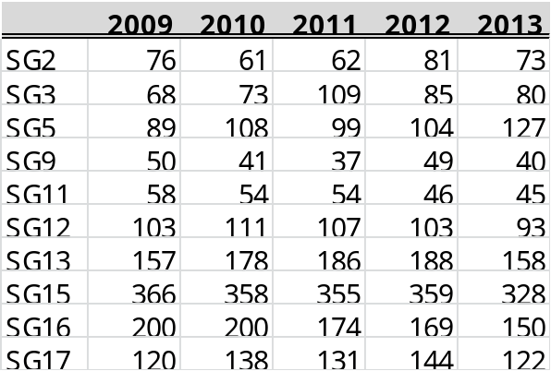

2.2.2 The numbers of contributions
Table 3 shows the average numbers of the contributions per SG meeting in the five-year period of 2009-2013.

Table 3. The average numbers of contributions per SG meeting
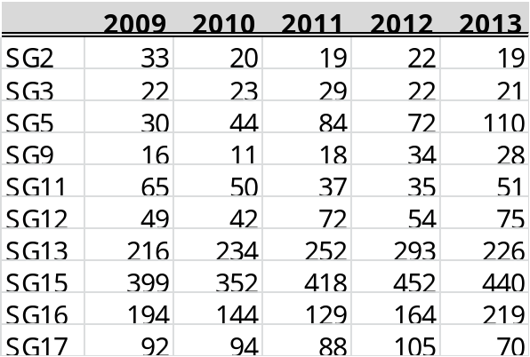

2.2.3 The numbers of outcome Recommendations
Table 4 shows the average numbers of the outcomes for each SG meeting in each year of the five-year period of 2009-2013. The outcomes include the approved Recommendations consented (under AAP) and determined (under TAP).

Table 4. The numbers of the approved Recommendations
 | 2009 | 2010 | 2011 | 2012 | 2013
SG2 | 12 | 9 | 13 | 5 | 9
SG3 | 1 | 3 | 2 | 3 | 0
SG5 | 9 | 5 | 18 | 16 | 2
SG9 | 4 | 11 | 12 | 10 | 4
SG11 | 13 | 17 | 14 | 18 | 7
SG12 | 12 | 3 | 17 | 13 | 7
SG13 | 18 | 15 | 25 | 23 | 16
SG15 | 57 | 89 | 50 | 109 | 64
SG16 | 65 | 33 | 34 | 49 | 53
SG17 | 11 | 11 | 59 | 64 | 21

2.2.4 The numbers of Liaison statements
Table 5 shows the numbers of the exchanged Liaison statements for each SG in each year in the five-year period of 2009-2013. The numbers include the Incoming and Outgoing Liaison statements for Action, for Comment and for Information in each year.

Table 5. The numbers of Liaison statements
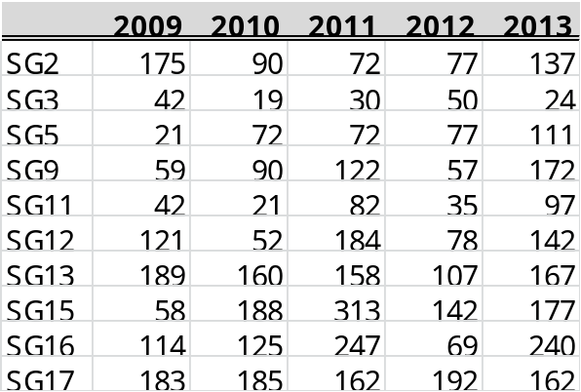

  - The numbers of the downloaded Recommendations
Figures 1 to 10 show the numbers of the top 5 downloaded Recommendations in each SG in each year of the period of 2009-2013. The selected Recommendations are shown in Annex 2 tables with highlighting their Recommendation numbers in green colour. The figures were developed based on the numbers of the top 10 downloaded Recommendations per year in each SG with the support of TSB. The vertical scales are adjusted in each SG to see the changes of the downloaded numbers.
Table ANNEX 1 shows the top 100 downloaded Recommendations in ITU-T in the five-year period of 2009-2013 for your information.
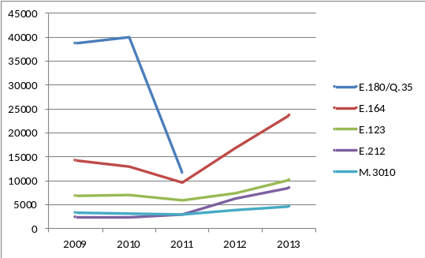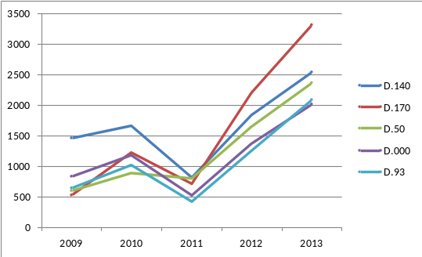
Figures 1: SG2 Figures 2: SG3
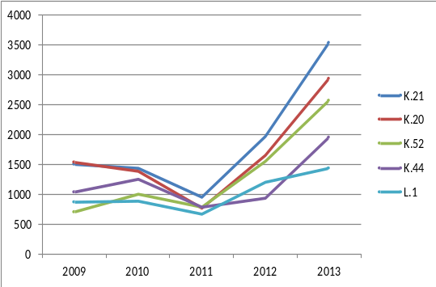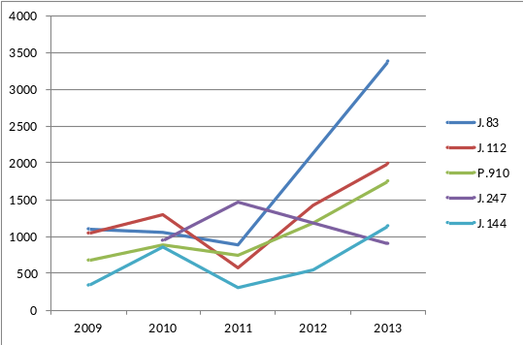
Figures 3: SG5 Figures 4: SG9
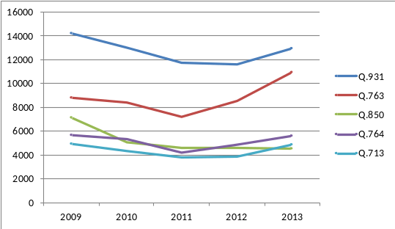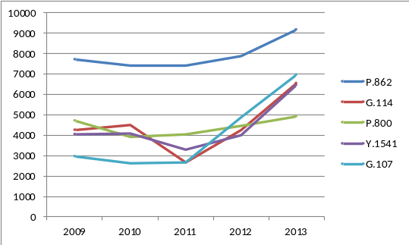
Figures 5: SG11 Figures 6: SG12
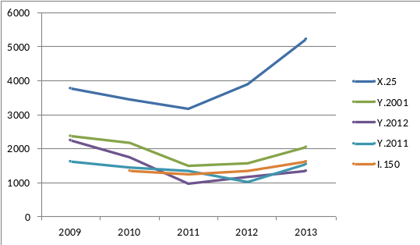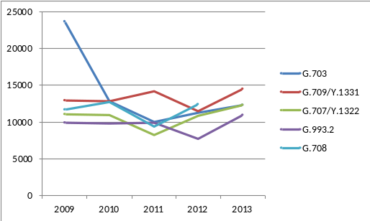
Figures 7: SG13 Figures 8: SG15
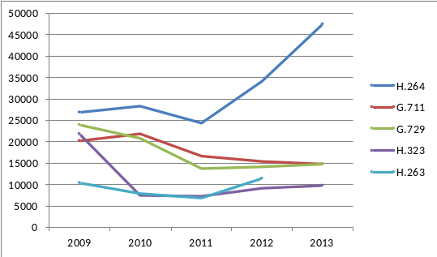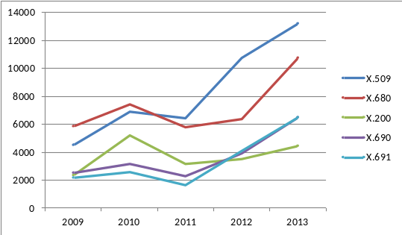
Figures 9: SG16 Figures 10: SG17

- Discussions
The measurement of the activities of each study group may produce some interesting results. To the extent that some activities may no longer generate a high degree of interest, as measured by the number of contributions submitted to meetings and the number of participants interested in the subject matter, it would be expected that the work programmes of study groups would be modified accordingly. More fundamentally, however, a key task of the Review Committee will be to assess the impact of the changes in the environment such as convergence which would impact the kinds of studies that will need to be undertaken in the ITU-T in the future. This could in turn have an impact on the structure and scope of the study groups in response to changing technologies and market needs.
The examples are shown by measuring the numbers of participants, contributions and outcomes in each SG including Recommendations and Liaison statements. Based on the comments raised in the Correspondence Group on the Action Plan, the numbers of downloaded Recommendations are measured to check whether they are really used/implemented in practice.
The metrics will have the counter effect to increase the number of small contributions and revised Recommendations. Also it should be noted that the download figures should be manipulated cautiously, as some automatic downloads (robot) may have impacted some of them.
The measured statics will be valuable to monitor the activities in SG in ITU-T but should be carefully evaluated whether they are really valuable metrics to be used for the criteria for the future study group restructuring to realize the efficient and effective standards development. The characteristics and uniqueness of each SG should be considered for the evaluation not to lose the important roles of ITU-T.
It is suggested for each SG management to review the statics to check the SG activities. In these statics, more detailed analysis with Question level has not been performed. It is also suggested for each SG management to check the Questions with no work items and/or no contributions and/or no Rapporteur and/or no participants and work items with no contributions and/or no Editor.
The collection is an outcome of standards activity survey supported by TSB. Based on the examples, the meeting is requested to study which criteria should be considered to measure the activities in each SG. Any contributions are requested for the future meetings.

ANNEX 1

Table Annex 1. Top 100 downloaded Recommendations from 2009 to 2013

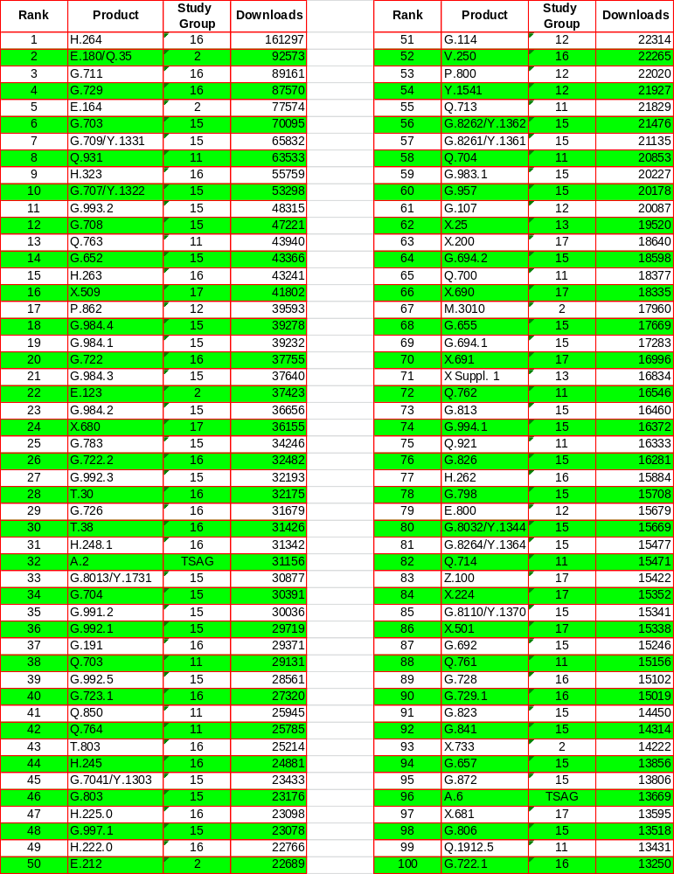

[Note] The download figures should be manipulated cautiously, as some automatic downloads (robot) may have impacted some of them.
ANNEX 2

Table I-1 Number of downloaded Recommendations in SG2
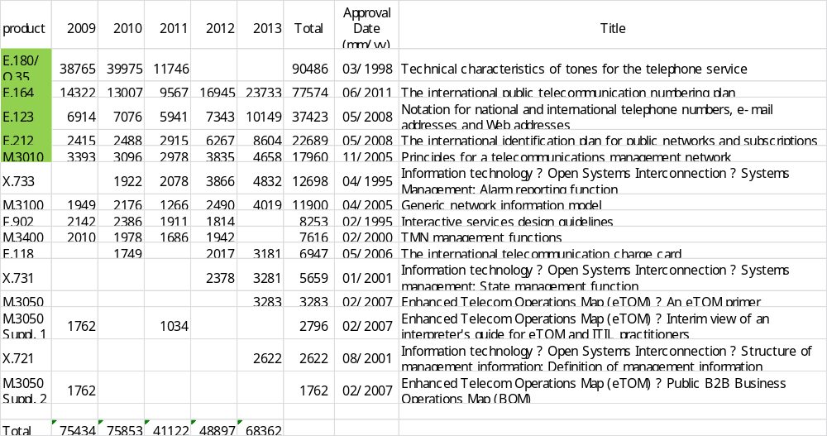

Table I-2 Number of downloaded Recommendations in SG3
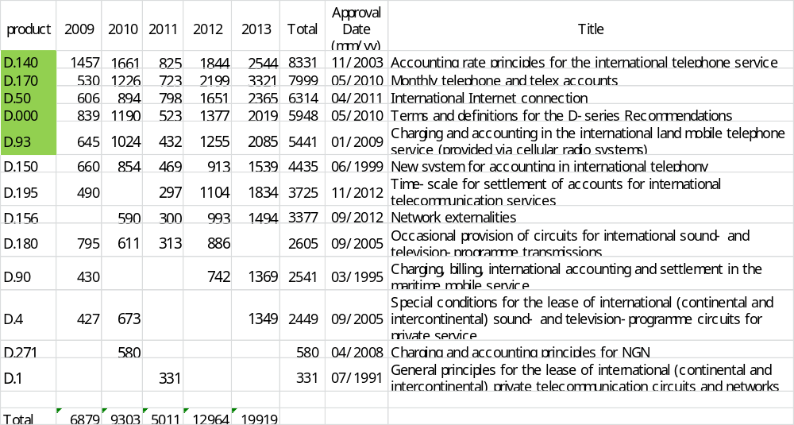

Table I-3 Number of downloaded Recommendations in SG5
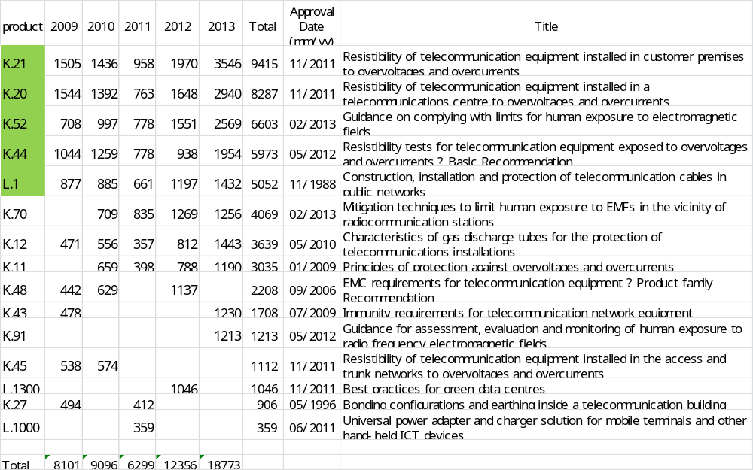

Table I-4 Number of downloaded Recommendations in SG9
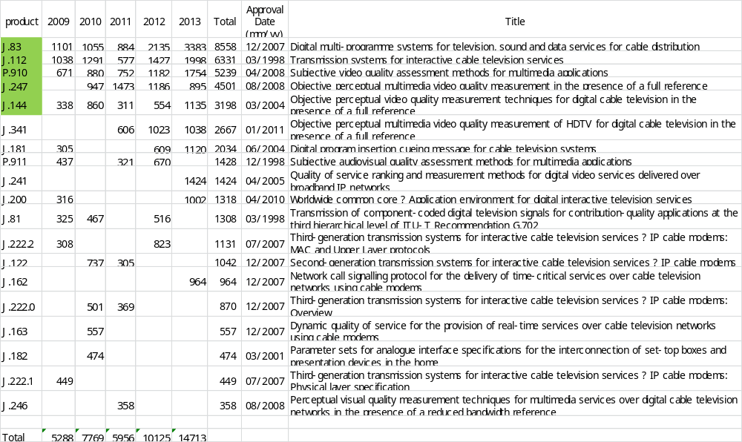

Table I-5 Number of downloaded Recommendations in SG11
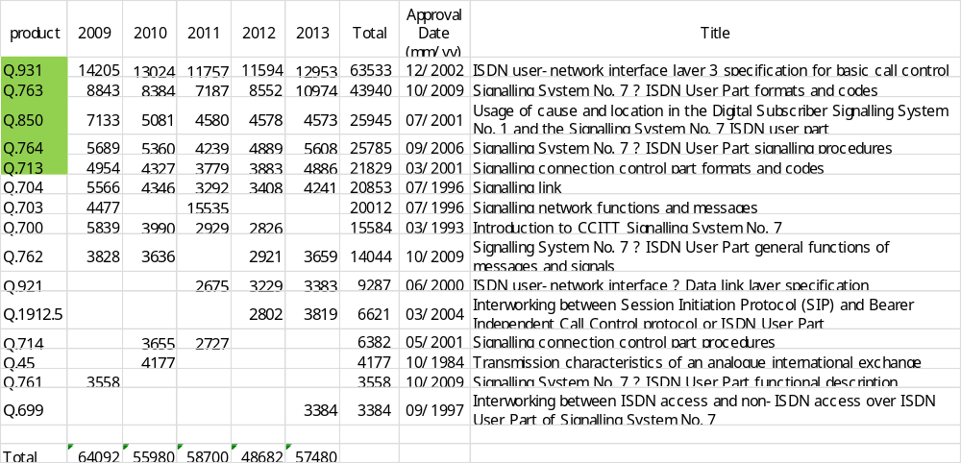

Table I-6 Number of downloaded Recommendations in SG12
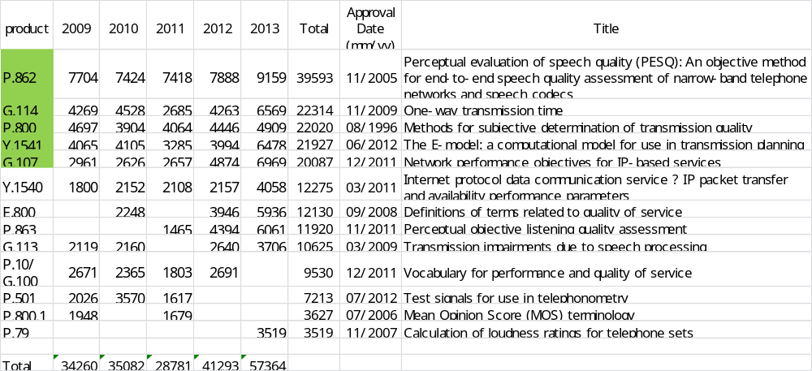

Table I-7 Number of downloaded Recommendations in SG13
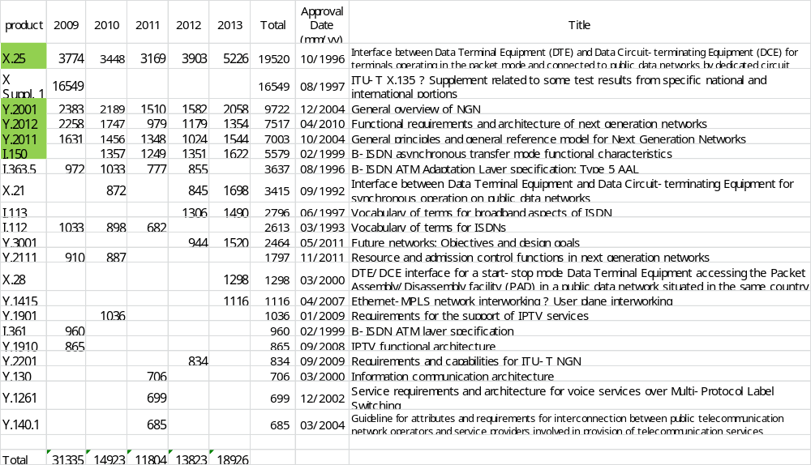

Table I-8 Number of downloaded Recommendations in SG15
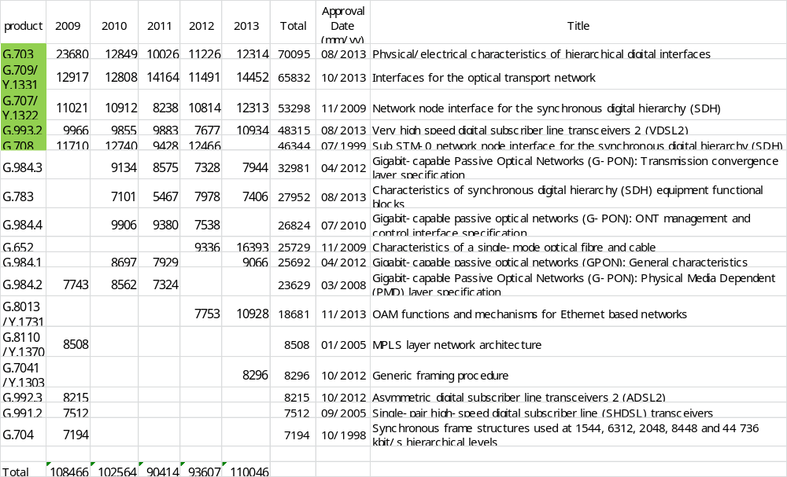
Table I-9 Number of downloaded Recommendations in SG16
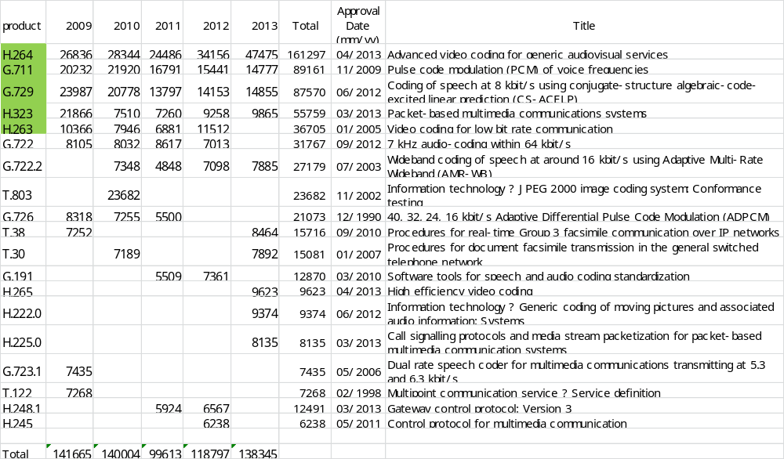

Table I-10 Number of downloaded Recommendations in SG17
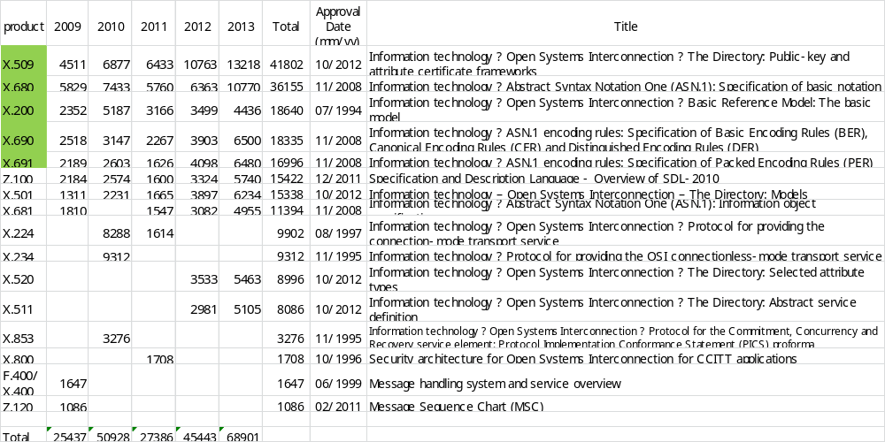
Please note that the download figures should be manipulated cautiously, as some automatic downloads (robot) may have impacted some of them.
_________________________

