Question(s): | VQEG |  | Meeting, date: |  |  | Rennes, June 11-15
Study Group: |  | Working Party: |  | Intended type of document (R-C-TD): |  |  | C
Source: | KDDI R&D Laboratories, Inc., Japan
Title: | Proposal to include evaluation of 4K resolution video and HEVC coding quality into the scope of future VQEG tests
Contact: | Osamu Sugimoto  KDDI R&D Laboratories, Inc.  Japan |  |  |  | Tel: +81-49-278-7416  Fax: +81-49-278-7439  Email: sugimoto@kddilabs.jp
Please don’t change the structure of this table, just insert the necessary information.

Summary
This contribution proposes that VQEG should use 4K resolution video sequences as SRC and HEVC (High Efficiency Video Coding) as HRC in the future validation tests.

Introduction
Recently, 4K video products are rapidly spreading even in the consumer market. Toshiba started selling the world’s first consumer TV set that supports a resolution of 3960x2160@60fps (QFHD) last year. Sony also announced to launch their first consumer grade 4K TV set in the near future. Storage and transmission of such high data rate contents, which is at least four times as much as that of 1080i HD, are expected to be possible by use of the new coding standard HEVC that drastically improves coding efficiency compared to those of the conventional coding standards. These facts indicate that the 4K will be one of the major high-definition video formats and the HEVC will be the most frequently-used video codec in the near future. KDDI therefore proposes that the assessment of 4K video and HEVC coding quality should be included into the scope of the future validation tests.

Proposals

2.1 4K format definition as SRC
The following 4K formats should be included into the SRC definition:
- 4K DCI for digital cinema (4096x2160@24fps, progressive)
- 4K-QFHD for broadcasting applications (3840x2160@24,25,30,50,60fps, progressive)

2.2 HEVC coding as HRC
HEVC coding with realistic coding conditions (e.g. random-access-capable setting for storage, low-delay setting for live network transmission, etc.) should be included into the HRC definition.

4K Test sequence availability and coding performance of HEVC
In this section, some information to collect test sequences is shown. In addition, we show a result of subjective test to survey the superiority of coding performance of HEVC to that of H.264.

3.1 Test sequences availability
- NICT 4K/3D contents
NICT provides 4K/3D contents, each channel of which has a format of 3840x2160@60fps. NTT introduces guidelines to use this test material.
ftp://vqeg.its.bldrdoc.gov/Documents/VQEG_Seoul_Jun11/MeetingFiles/3DTV/VQEG_3DTV_2011_015_Distribution of 3D standard contents.doc
- SVT High Definition Multi Format Test Set
SVT test sequence set includes the footages of 3840x2160@50fps. You can download them from the VQEG ftp server. For details, see the following documents.
http://svt.se/content/1/c8/02/02/85/31/svt_multiformat_v10.pdf
ftp://vqeg.its.bldrdoc.gov/HDTV/SVT_MultiFormat/2160p50_CgrLevels_Master_SVTdec05
- DCI/STeM
Digital Cinema Initiatives (DCI) provides Standard Evaluation Material (StEM) for the purpose of industry standardizations, trade show demonstrations, education, etc. Maximum resolution of the test sequence is 4096x1714. You need to sign the user agreement.
http://www.dcimovies.com/StEM/

3.2 Subjective quality assessment of PVS coded by HEVC
A subjective test was conducted to analyze coding performance of HEVC. 14 test sequences were chosen from KDDI’s own 4K test sequence pool. They have a format of QFHD(3840x2160)@30fps and were coded by HM6.1 (reference encoder of HEVC) at 4, 8 and 16Mbps. They were also coded by H.264 JM 15.1 at 8,16 and 32Mbps for comparison. Subjective scores were collected based on the DSCQS test with 24 subjects.
Figure 1 shows the comparison of DMOS scores between HEVC and H.264 for each PVS. The DMOS of PVSs coded by HEVC at 4,8,16Mbps with GOP structure of IBBBBBBBBBBBBBB are compared with those coded by H.264 at 8,16,32Mbps with GOP structure of IBBPBBPBBPBBPBB, respectively. Each label in the figure indicates the coding bitrate of HEVC. When we compare the subjective quality of PVSs coded by HEVC with those coded by H.264 at twice as much bitrate as that of HEVC, 35% of total number of PVSs coded by HEVC have better subjective scores than those coded by H.264. When we compare the performance of HEVC and H.264 at the same bitrate, 52 % of all PVSs coded by HEVC are better than those coded by H.264 in terms of DMOS. These results indicate that HEVC is promising to realize better coding efficiency than the conventional coding standards and it is more suitable for storage and transmission of 4K video.

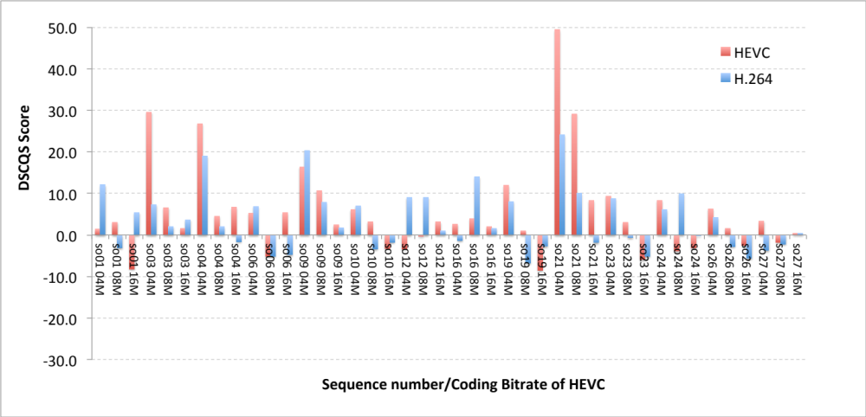
Figure 1 Comparison of subjective scores between HEVC and H.264

Conclusions
As 4K and HEVC will possibly be a part of the mainstream of future video services, VQEG should begin to study on them. The HDTV phase2 test seems to be a good opportunity of the first study, but the opportunity is not limited to that. Any other VQEG tests may include 4K and HEVC into its scope.

